Feedback from Imtac about latest Metro double deck bus design

Background
Imtac has a clear position on the future of bus procurement in Northern Ireland including the purchase of low-floor vehicles only in future and the purchase of vehicles that can be used by more than one wheelchair user. Since 2021 Imtac has been working alongside Translink, Department for Infrastructure and the Consumer Council on group reviewing future bus procurements including vehicles used to deliver Belfast and Foyle Metro, Ulsterbus and Goldline.
The Group has been working through procurement frameworks for the different types of vehicles operated by Translink with agreement reached to date on most vehicle designs. These frameworks are designed primarily for future vehicle purchases, however, Imtac requested that, if possible, these agreed designs be used for purchases under current frameworks. Minister O’Dowd wrote to Translink requesting this.
Translink introduced the first Metro double deck vehicles with two spaces that can be used by wheelchair users in early 2025. No consultation took place with Imtac about the specific design of these buses. In discussions with Translink the Committee was informed by Translink that the vehicle design was to be piloted to inform future procurement. Imtac requested that part of this pilot include user testing and feedback. A user testing session was held at Grand Central Station on the 26th November 2026.

Feedback from user testing
Around 20 people attended the user testing session at Grand Central Station on the 26th of November 2025. Participants included wheelchair users, people with visual impairment, people with walking difficulties and people with learning difficulties.
Broadly the feedback was overwhelmingly positive from participants with a consensus that this type of design should form the basis of future vehicle procurement.

Key positive points included:
- The two wheelchair spaces are generous and were accessed by users with larger wheelchairs with relative ease.
- The second space is particularly generous, enabling sharing of the space for different users – for example a wheelchair user and a person with a buggy or rollator.
- Other features including the provision of floor markings to indicate wheelchair user priority were welcomed.
- The provision of additional visual screens both upstairs and downstairs accessible to wheelchair users were welcomed.
- The flexibility of space on the lower level was welcomed with a
range of seating options.
Participants also made some comments about how access could be improved further including:
- Providing a ramp on the second door of the vehicle to enable easier boarding and alighting and access to spaces for wheelchair users.
- Allowing the second door to be used by people with mobility difficulties to ease boarding and alighting and enable easier access to priority seating and space.
- Improving the readability of visual display screens in consultation with Deaf and disabled people.
Images have been included in Appendix A illustrating issues raised in the feedback.

Recommendations from Imtac
It is clear from the user testing that the vehicles were broadly welcomed as a major step forward in terms of accessible and inclusive design. From the Committee’s perspective we recommend that all future vehicle procurement include key aspects of the design including provision of two spaces that can be used by wheelchair users.
Based on feedback there are some additional specific
recommendations. Where vehicles have dual doors we recommend that ramps are provided at both doors and that wheelchair users and other passengers can use the second doors.
The first dual door double deck vehicles purchased by Translink included ramps on both sets of doors on the advice of Imtac. It is disappointing a second ramp was not included on these pilot vehicles, but it does emphasise the importance of engaging with Imtac and others. We recommend that in future Imtac is consulted on any changes to the design of vehicles at the earliest possible stage.
The Committee recognises that effective dual door operation of buses is heavily dependent on the accessibility of bus stops and that the majority of stops in Belfast do not facilitate their operation. It is essential that this situation is improved, if we are to maximise the accessibility of new bus design. We recommend the Department publish a revised bus stop design guide as a matter of urgency, specifically including designs that maximise the access for dual door buses. We further recommend that new bus stops where dual door buses operate are required to meet these requirements and plans are developed to upgrade existing infrastructure.
The Committee is conscious that ticketing issues may be a barrier to passengers using secondary doors for boarding. We recommend that discussions take place now between Imtac, the Department and Translink to identify ticketing solutions that will enable second door boarding.
Whilst the provision of additional visual display screens has been broadly welcomed, comments have been made about the readability of screens on both Belfast and Foyle Metro. We recommend that Translink review the layout of visual display screens in consultation with Imtac and Deaf and disabled people to maximise their accessibility and usability.
Next steps
The introduction of vehicles with two spaces and other enhanced accessibility features are welcomed and commended by Imtac. We believe this demonstrates the positive engagement that has taken place between the Committee, Translink and the Department around future bus procurement and it is essential this continues. We firmly recommend that the recently introduced vehicle form the template for future vehicle purchases. The Committee has made some specific recommendations about the current vehicle design, and we would welcome further discussion about addressing and implementing these recommendations.
Appendix A – Images of user testing day
Picture 1 – Wheelchair spaces are generous enabling access for users with different sizes of chairs.
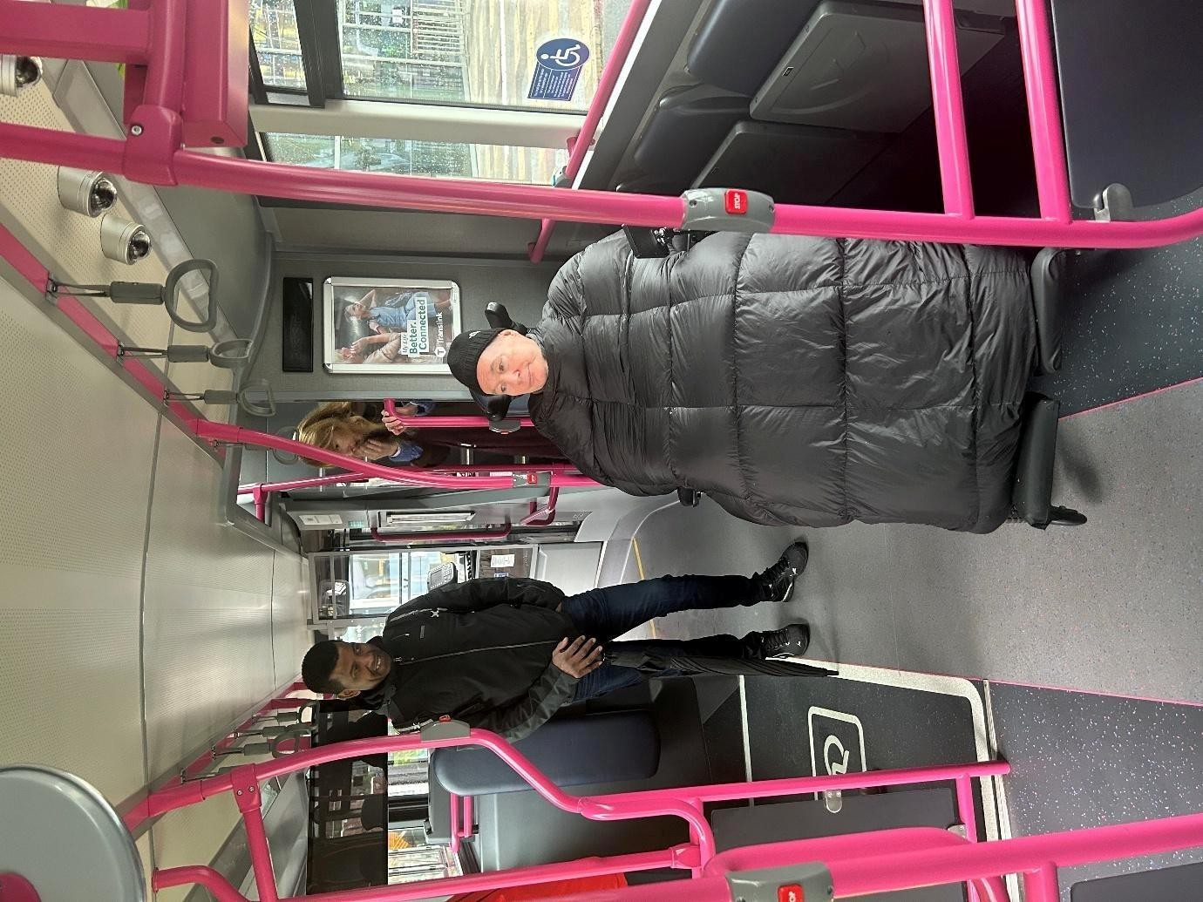
Picture 2 – The vehicle accommodates two wheelchair users comfortably. Floor markings indicating priority are a welcome addition.
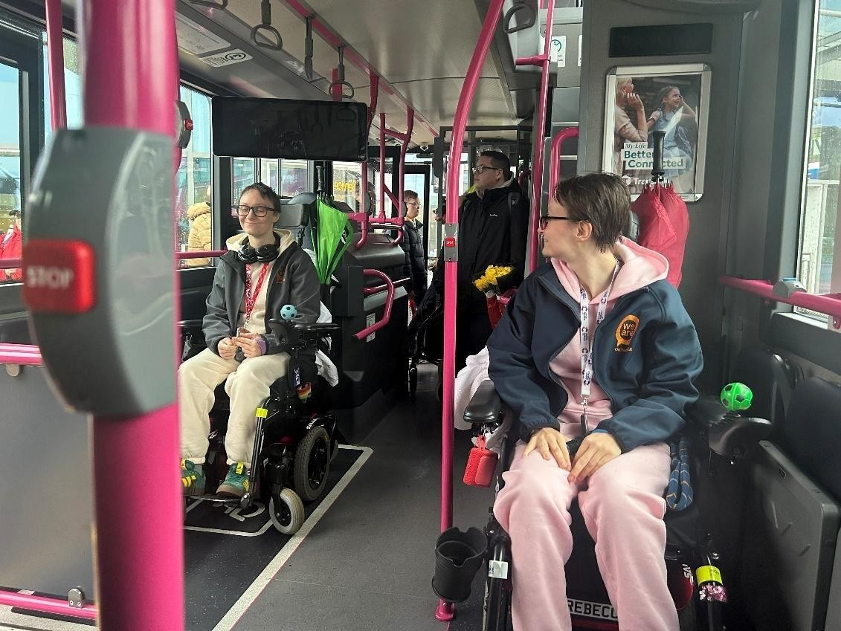
Picture 3 – Image shows longer priority space illustrating sharing between users, in this case a wheelchair user and a person with a rollator.
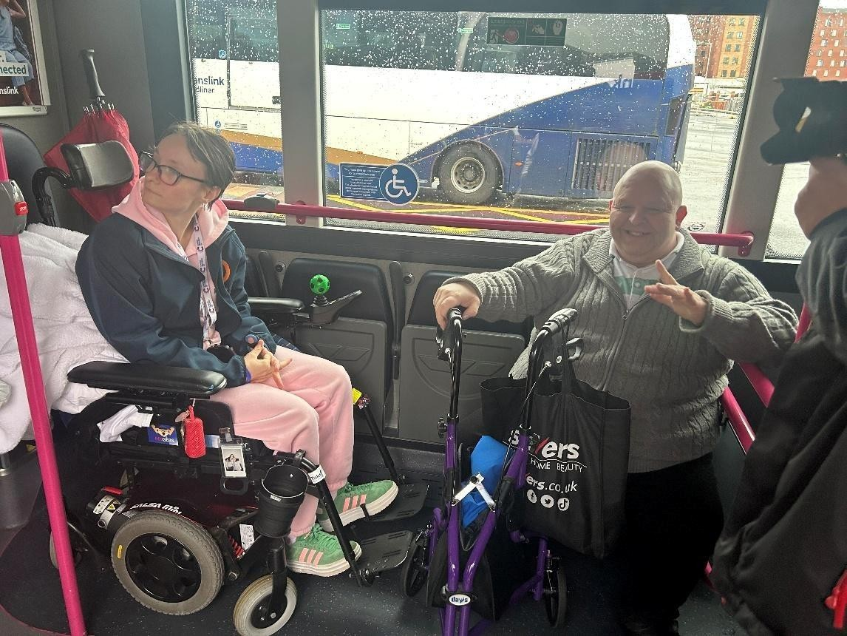
Picture 4 and 5 – Pictures illustrate the welcome provision of visual display screens onboard. Readability / usability issues have been raised about larger screens.
