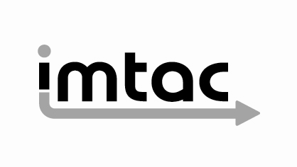

Recommendations from Imtac on future Translink bus procurement
April 2018

Imtac is committed to making information about our work accessible. Details of how to obtain information in your preferred format are included on the next page.

Making our information accessible

As an organisation of and for disabled people and older people Imtac recognises that the way information is provided can be a barrier to accessing services and participation in public life. We are committed to providing information about our work in formats that best suit the needs of individuals.

All our documents are available in hard copy in 14pt type size as standard. We also provide word and pdf versions of our documents on our website – www.imtac.org.uk. In addition we will provide information in a range of other formats. These formats include:

• Large print
• Audio cassette or CD
• Daisy disc
• Braille
• Electronic copies on disc or via email in PDF or word
• Easy read
• Information about our work in other languages

If you would like this publication in any of the formats listed above or if you have any other information requirements please contact:

Michael Lorimer
Imtac
Titanic Suites
55-59 Adelaide Street
Belfast BT2 8FE

Telephone/Textphone: 028 9072 6020
Email: info@imtac.org.uk

About Imtac

The Inclusive Mobility and Transport Advisory Committee (Imtac) is a committee of disabled people and older people as well as others including key transport professionals. Its role is to advise Government and others in Northern Ireland on issues that affect the mobility of older people and disabled people.

The aim of the Committee is to ensure that older people and disabled people have the same opportunities as everyone else to travel when and where they want.

Imtac receives support from the Department for Infrastructure (hereafter referred to as the Department).

Introduction

Disabled people and older people face significant barriers to accessing everyday services such as transport. These are created by how services, the built environment and society in general is designed. In its submission to the development of a new Accessible Transport Strategy Imtac identified a number of barriers that continue to make travel difficult including a lack of available and accessible information, the attitudes of people who design and provide transport services and a lack of engagement with disabled people and older people in developing and designing services. Whilst addressing each of these is vital in delivering an accessible and inclusive transport system, nothing can be achieved without addressing the physical accessibility of transport vehicles and infrastructure.

Since January 2018 Translink has been engaging with its stakeholders and passengers to inform future designs of vehicles to be used on Metro, Ulsterbus and Goldline services. As part of this process Imtac members attended a stakeholder event at the Europa Buscentre and a separate visit to Wrightbus in Ballymena. Imtac welcomes this positive and proactive approach undertaken by Translink. Based on this recent engagement and previous work undertaken by Imtac, the Committee has developed this paper to summarise its advice to Translink and the Department on how the design of vehicles purchased in future can address reduce and remove the physical barriers to travel currently experienced by many older people and disabled people.

Strategic background

Imtac’s advice on vehicle design is informed and underpinned by the obligations placed on the Northern Ireland Government by the UN Convention on the Rights of People with a Disability (UNCRPD) as well as policy commitments previously made by both Translink and the Department.

Article 9 of the UNCRPD places the following obligation on signatory states:

“To enable persons with disabilities to live independently and participate fully in all aspects of life, States Parties shall take appropriate measures to ensure to persons with disabilities access, on an equal basis with others, to the physical environment, to transportation, to information and communications, including information and communications technologies and systems, and to other facilities and services open or provided to the public, both in urban and in rural areas.”

Both the Department and Translink have made broad, positive strategic commitments to accessibility and inclusion which are consistent with the obligations of Article 9 of the UNCRPD. The draft Delivery Plan for the Programme for Government (PfG) relating to Indicators 23, 25 and 47 gave the commitment “to have a transport network that is inclusive and accessible to all”. Translink have made a similar commitment “to deliver a transport network in Northern Ireland that is inclusive and accessible to all.”

Key principles for future vehicle procurement

Imtac recommends that Translink and the Department adopt the following key principles to inform decisions on future bus procurement.

1 Future decisions must be based on inclusive design principles

If public transport is to be genuinely “public” and meet the commitments made by both the Department and Translink, inclusive design must be the guiding principle for future vehicle procurement. Imtac recommends that the primary consideration underpinning future vehicle purchases is that they are accessible, and usable, by as many people as possible. Inclusive design means designing for people of all ages (both young people and older people), both disabled people and non-disabled people and people with dependents including carers and those with babies and toddlers. Imtac believes this can be achieved through implementation of the following measures.
2 Vehicles must be step free

Steps are the most basic physical barrier that routinely excludes disabled people, older people and others from transport and other services and the wider built environment. In the future vehicle procurement must ensure that steps are removed from buses.

From Imtac’s perspective this means that all vehicles purchased in the future must contain only one step at the entrance to the vehicle after which there should be a low-floor section without further steps. A ramp at the entrance to the vehicle provides a step-free aid to boarding and alighting. The Committee also promotes the use of bus boarding kerbs at bus stops and standings, which significantly reduce the step height when boarding and alighting.

Currently Translink operates a significant number of high-floor single deck coaches with a number steps at the entrance and within the interior of the vehicle. The design of these coaches makes it difficult or impossible for some disabled people, older people and others to use these services. Stepped access to vehicles is incompatible with inclusive design principles and the continued future use of this type of vehicle will make it impossible for Translink and the Department to meet its published commitments. More importantly the continued use of this type of vehicle will mean that disabled people will continue to be denied equal access to public transport compared with others in our society.

3 All vehicles must have dedicated priority space for wheelchair/scooter users

In line with Article 9 of the UNCRPD Imtac believes that wheelchair and scooter users have the right to travel on an equal basis with other passengers. To enable spontaneous travel, vehicles must have a priority space for the use of wheelchair users when required. Currently whilst all low-floor buses have a priority wheelchair user space, single and double-deck coaches have seating in this space that must be removed before a wheelchair user can use it. It is Translink policy that wheelchair and scooter users must give notice 24 hours in advance to use services where these vehicles operate. In addition the space required to deploy passenger lifts safely on single deck coaches makes their use impossible in many locations, limiting and restricting the locations where wheelchair and scooter users can access these vehicles compared with other passengers.

Imtac has been clear in its previous advice provided to Translink and the Department that the requirement for disabled people to give notice to use public transport is unacceptable and must end. It recommends that in future all vehicles purchased must provide a separate priority space for wheelchair and scooter users. To emphasize the purpose of the space, and to reduce conflict with other passengers, Imtac suggests that the floor area within this space includes a wheelchair user symbol. Further discussion is required to agree a consistent design of the designated wheelchair user’s space including the type and positioning of handrails in the area. However the agreed design must maximise the dimensions of the space (within regulatory requirements) to ensure ease of access for wheelchair and scooter users.

Given the access restrictions of single deck coaches the Committee believes that only low-floor vehicles can provide the level of access required to enable wheelchair and scooter users to travel by public transport on an equal basis with other passengers.

4 All vehicles must provide additional flexible space for other passengers

There are many other passengers that also require additional space on board vehicles. These include passengers with assistance dogs, bulky mobility equipment such as a rollator, a buggy or a pram and bulky items and luggage. Whilst some of these passengers may use the priority wheelchair users space when it is not required by a wheelchair or scooter user it is essential that vehicles contain another flexible space that can be used by them when a wheelchair or scooter user is travelling. The provision of this additional flexible space is consistent with inclusive design principles. The provision of additional flexible space reduces the potential conflict between passengers competing for the limited space on vehicles. During the recent engagement process members saw some good examples of low-floor buses that provide additional flexible space; however members also saw that it is very difficult or impossible to provide such space using the current design of Translink’s single deck or double-deck coaches.
More work is required to agree the ideal configuration of the space on a bus but Imtac recommends the inclusion of a second wheelchair or scooter user space for future bus purchases (this has recently been included in new vehicles recently purchased by Reading Buses).
5 Future buses do not include “modesty boards”
Most Translink vehicles currently use modesty boards around hand and grab rails provided within the wheelchair user’s space, flexible space or other priority seating. Imtac recommends that in future new buses do not include modesty boards as these restrict the accessibility and comfort levels of what is already a somewhat confined space. Vehicles viewed by members during the visit to Wrightbus did not have modesty boards and there is no legislative requirement on Translink to do so. Consideration should also be given to removing modesty boards from the existing vehicle fleet.
6 Vehicles must provide a full range of accessible design features
In addition to step free access, priority space for wheelchair users and additional flexible space future vehicle purchases must also include the following features, essential if inclusive design principles are to be met:
• Handrails and grab rails, particularly in the step-free area of vehicles to assist passenger to get to and from the seats.
• Frequent provision of bell pushes, easily accessible and easy to use from seating in the step free area, giving passengers the opportunity to alert drivers without leaving their seats (bell pushes which require passengers to reach above their heads are not considered by Imtac to be accessible).
• Generous aisles and gangways to facilitate easy access to and from seating in the step-free area of vehicles.
• Four forward facing priority seats for the use of disabled passengers.
• The use of colour contrasting materials throughout the vehicle.

Currently legislation requires low-floor buses to include all of these features. Single and double deck coaches are not required to provide all of these essential features. It would be extremely difficult, if not impossible, to provide the full range of accessible design features on Translink’s current single deck coaches in particular.

7 Vehicles must include provision for audio and visual next stop information

Imtac views the provision of audio and visual next stop information as an essential component of accessible public transport, vital to ensuring that disabled people and older people can use services on an equal basis with other passengers. The provision of this facility on Metro buses has proved successful and popular with all passengers, not just disabled passengers. The Committee recommends that proposals be developed to extend the provision of audio visual information across the entire Translink network. It also recommends that future systems be enhanced to include, for example, the facility for drivers to request passengers to move from priority seating if it is required by a disabled person. Such a facility is part of the iBus system used on buses in London.

8 Vehicle procurement must address the current service disparity between rural and urban areas

All stepped access coaches are currently exclusively used on Ulsterbus and Goldline services that operate inter-urban and rural services. Regional town services and Metro services in Belfast and Foyle use exclusively low-floor buses. Disabled people and older people living in rural areas already face many barriers to using public transport including the distance to and the frequency of services and a lack of accessible infrastructure. Using vehicles to which are difficult or impossible to access to deliver these services not only compounds these barriers, it is also incompatible with obligations under Article 9 of UNCRPD and potentially ignores the duties of the Department to rural proof its policies.
Imtac recommends that in future vehicle procurement policies treat the access requirements of disabled people and older people living in rural areas of Northern Ireland on an equal basis to those of people living in urban areas.
Branding and premium services

The Committee recognises the importance of current Goldline services, providing a distinctly branded, premium service designed to encourage commuters and others to use public transport over the private car. It also understands that in providing such a premium service passengers have the expectation that additional features such as high quality seating, WiFi, USB and other charging facilities will be provided on board these vehicles.

As with other passengers disabled people and older people want and benefit from the additional features included on premium Goldline services. However the predominant use of coaches and their design, effectively rules out their use by many disabled people and older people. If the commitments made by both the Department and Translink to make all services inclusive and accessible are to be met, vehicle design must change, moving from stepped access coaches to high quality low-floor bus design incorporating the features mentioned above.

In previous work Imtac has identified a number of examples from Great Britain of premium services which are delivered using low-floor vehicles. Services such as Stagecoach Gold, Arriva Sapphire and the Transdev 36 and Coastliner services in Yorkshire combine inclusive and accessible design with high quality interiors. These services can provide Translink with a template for the future development of premium bus services here, proving beyond any doubt that accessibility and quality are not mutually exclusive.

The Appendix included with this paper highlights examples of what Committee members consider to be good practice for an inclusive, premium bus service design.

Conclusion

Imtac thanks Translink and the Department for the opportunity to discuss the future of vehicle procurement. This paper reflects its members desire to assist Translink and the Department to meet the positive commitments they have made to accessibility and inclusion. It also demonstrates Imtac’s commitment to ensuring that in the future disabled people and older people can use public transport on an equal basis to others.

The Committee recognises that removing current physical barriers to travel within the Translink fleet will take time and is dependent on resources being available to replace ageing vehicles. However it is important that Imtac’s recommendations are implemented at the earliest opportunity to maximise procurement opportunities. Imtac would suggest that initially Translink prioritise vehicle enhancements on specific routes. This approach would have two advantages. Firstly it would provide disabled people and older people with the certainty that every vehicle on these routes are accessible. Secondly it would enable Translink to monitor the impact of new vehicle designs.

Imtac is aware that some of its recommendations challenge current policies and practices on vehicle procurement. However Translink and the Department will recognise that equality, no matter where, has never been achieved without challenging and moving away from what is considered the “norm”. The Committee encourages both to implement the changes it recommends, in doing so it will open up the option for many more people to use public transport and, at the same time, ensuring our transport system adapts to an ageing society.

Appendix – Best practice examples of inclusive bus design

Vantage - Greater Manchester

Vantage is a premium bus service in the Greater Manchester area operated by First Bus.

(Image shows the exterior of the low-floor double deck Vantage bus)

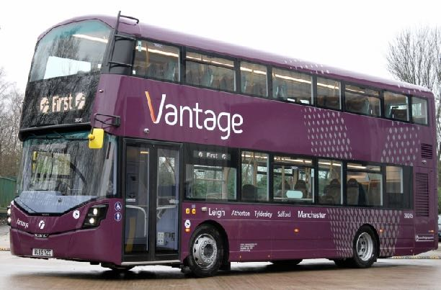
The vehicles include luxury leather effect seating, free WiFi, USB charging points and audio/visual next stop announcements. Downstairs the vehicle has a dedicated wheelchair user space with flexible space for other users. No modesty boards have been used, making the space generous and more accessible.
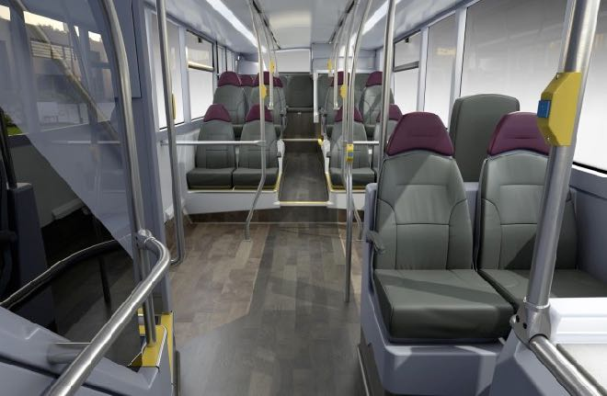

(Image shows the downstairs interior of the Vantage bus)
Upstairs aircraft style seating has been provided as well as some tables. Easy to use bell pushes have been provided throughout the bus.

(Image shows the upstairs layout on the Vantage bus)

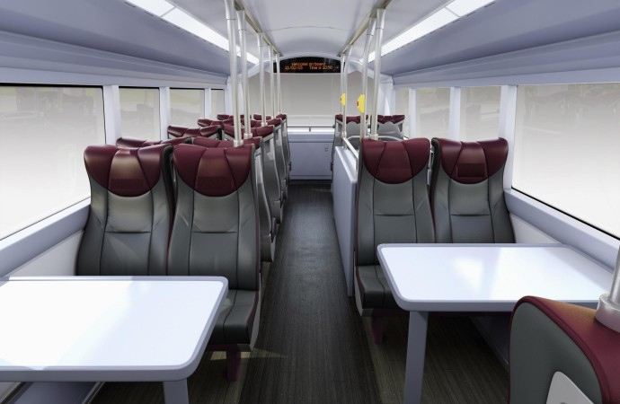
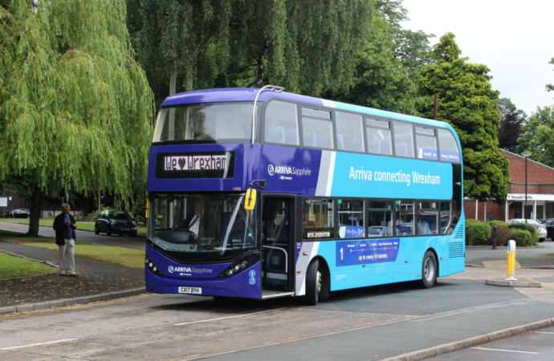
Arriva Sapphire - Nationwide

Sapphire is the brand name for a premium bus services operated by Arriva across Great Britain.

(Image shows the exterior of a low-floor double deck Sapphire bus)

The vehicles include luxury leather effect seating, free WiFi, USB charging points and audio/visual next stop announcements. Downstairs the vehicle has a dedicated wheelchair user space with some additional flexible space for other users. Again no modesty boards have been used, making the space generous and more accessible.

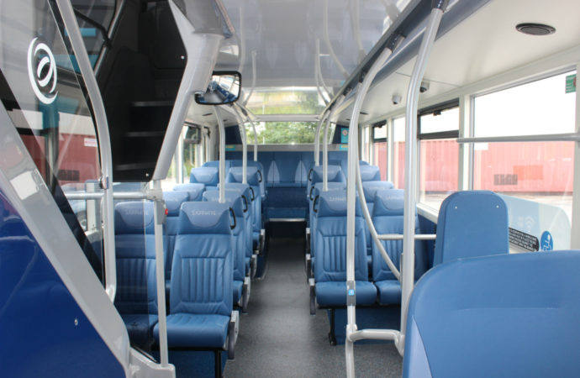
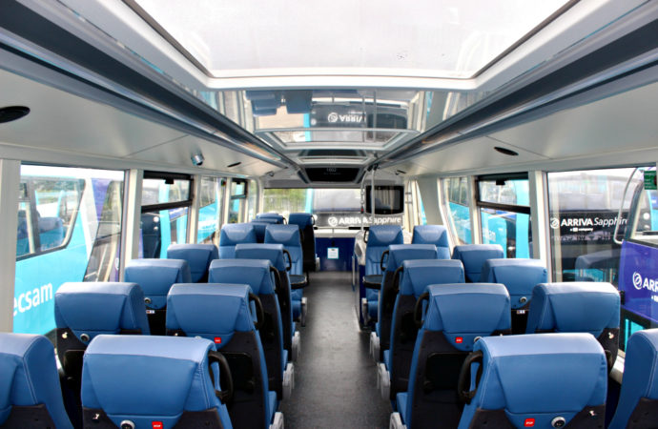

(Image shows the downstairs interior of the Sapphire vehicle)

Upstairs aircraft style seating has been provided as well as some tables. A skylight roof makes the space light and modern. Easy to use bell pushes have been provided throughout the bus.

(Image shows the upstairs layout of the Sapphire vehicle)

Transdev Coastliner & No 36 services - Yorkshire

Transdev operates a number of premium bus services in Yorkshire. The Coastliner operates between Leeds and York and coastal towns such as Whitby. The No 36 operates between Ripon, Harrogate and Leeds.

(Images show the exteriors of the Coastliner and No.36 low-floor buses)

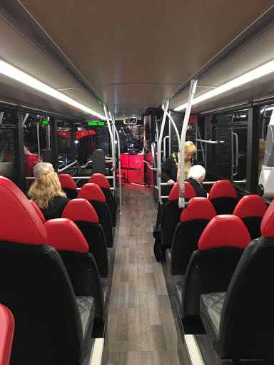
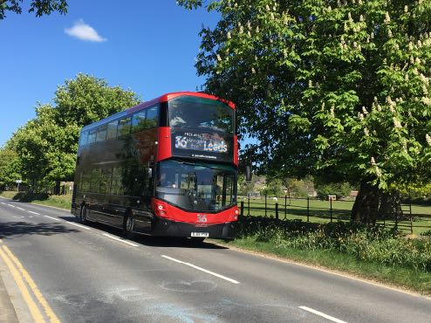
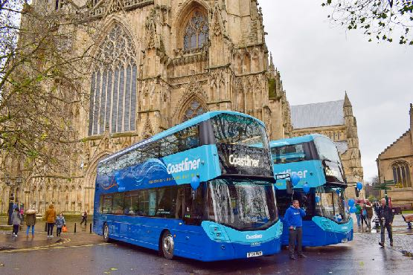
The vehicles include luxury leather effect seating, free WiFi, USB charging points and audio/visual next stop announcements. Downstairs the vehicle has a dedicated wheelchair user space with some additional flexible space for other users. Again no modesty boards have been used, making the space generous and more accessible.
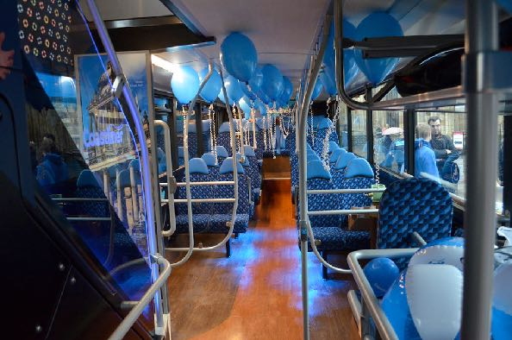

(Images show the downstairs interior of the Coastliner and N0.36 buses)

Upstairs aircraft style seating has been provided as well as some fixed and aircraft style tables. A skylight roof makes the space light and modern.
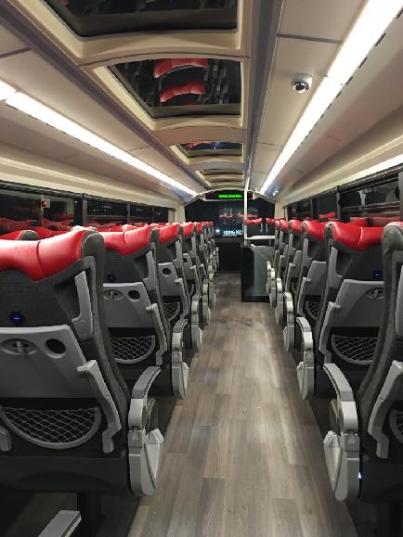
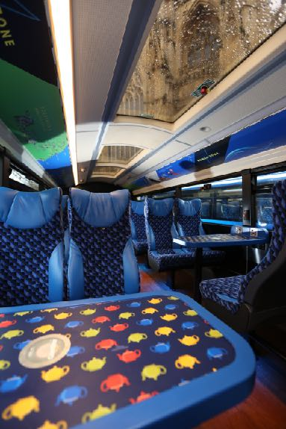
(Image shows the upper deck on both the Coastliner and No.36 buses)

Stagecoach Gold - Nationwide

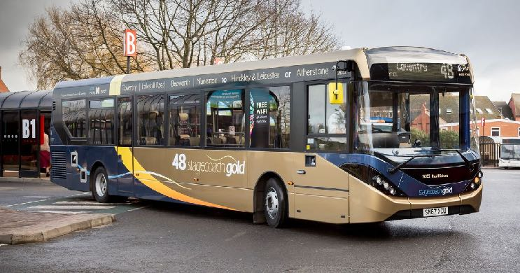
Gold is the brand name for premium bus services operated by Stagecoach across Great Britain.
(Image shows a single deck low-floor Gold bus)

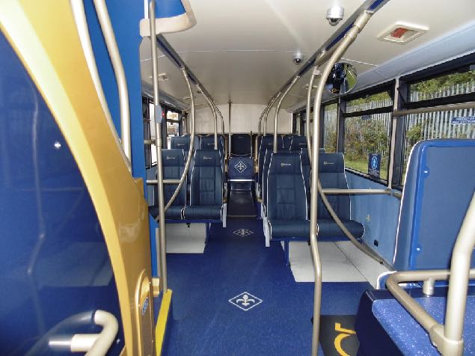
The vehicles include luxury leather effect seating, free WiFi, USB charging points and audio/visual next stop announcements on some services. Vehicles have a dedicated wheelchair user space with some additional flexible space for other users. Again no modesty boards have been used, making the space generous and more accessible.

(Image shows the downstairs layout on a Gold double deck bus. A wheelchair user symbol has been incorporated on the floor of the vehicle to emphasize the purpose of priority space.)

The Accessible Transport Strategy (ATS) 2025: Our views on the vision, strategic priorities and how to measure success for a new ATS
https://www.un.org/development/desa/disabilities/convention-on-the-rights-of-persons-with-disabilities/convention-on-the-rights-of-persons-with-disabilities-2.html
https://www.northernireland.gov.uk/sites/default/files/publications/newnigov/dp-average-journey-time-on.PDF
http://www.translink.co.uk/Documents/Corporate/publications/CorporatePlan/TranslinkStrategy2017.pdf
Imtac recognises that current accessibility regulations mean that vehicles are mainly designed to accommodate wheelchair users whose wheelchair meets the reference dimensions included in PSVAR.
Imtac recognises that only scooters that have been approved under Translink’s Scooter Policy can travel on buses and coaches.

