Glider update – May 2018

About this update

Over the past few years Imtac has been working with the Department for Infrastructure and Translink to make sure that the new Glider service will be accessible and inclusive. This update will highlight the key features on Glider and how older people and disabled people have been involved in its design.

What is Glider?

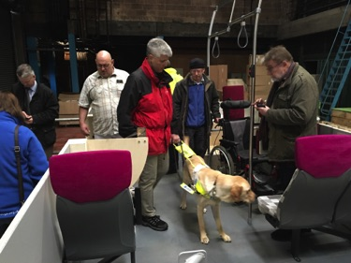
Glider is the name of the new Belfast Rapid Transit service which will start in September 2018. Glider will operate on two routes. The first route will run across East and West Belfast. The second route will run around the City Centre and out to the Titanic Quarter. The service will be operated by Translink.

Glider vehicles

Imtac members were involved at the early stage of designing Glider vehicles, including an event where older people and disabled people had the opportunity to comment on a mock-up of the vehicle.

(Image shows people viewing the mock up of the Glider vehicle.)

The new Glider vehicles are longer than most buses and have three doors for passengers to get on and off.

(Image shows exterior of the Glider vehicle with the first door open and boarding ramp deployed.)

The space in the front section of the vehicle has been designed to be flexible, accessible to a range of passengers. The main features of the Glider vehicle include:

  - The first set of doors are equipped with a boarding ramp to ensure step free easy access.
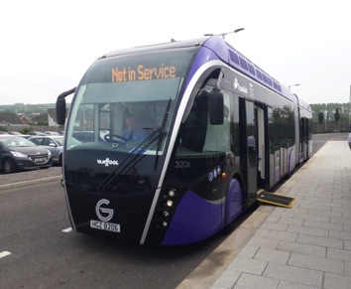
  - A dedicated wheelchair user’s space, located directly opposite the first set of doors, ensuring access is easier than most other public transport vehicles.
  - Four dedicated priority seats for the use of disabled people provided in the front section.
  - The front section also includes a flexible space with flip down seats, suitable for passengers with mobility aids and assistance dogs.
  - On-board next stop audio and visual passenger information and CCTV.
  - Easy access handrails and bell pushes throughout the vehicle.
  - Strong colour contrasting throughout the vehicle.
  - A separate space for prams and buggies in the rear section of the vehicle.

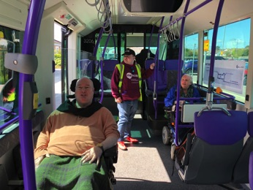

(Image shows Imtac members on-board the front section of Glider which includes flexible space with flip-down seats, 4 dedicated priority seats and a priority wheelchair user space.)

Imtac organised an event for older people and disabled people to give their feedback about the Glider vehicles on the 10th May 2018. Feedback from people who attended the event was positive. Suggestions from participants centred on encouraging passengers to give up priority seating if required by disabled people and older people, using better signage and the on-board audio visual information system.
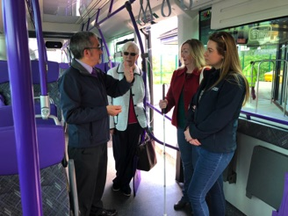

(Image shows attendees at the event in discussion on board Glider.)
Glider Halts

Passengers will get on and off Glider at newly installed halts along the two Glider Routes. Older people and disabled people were involved in the design of the halts.
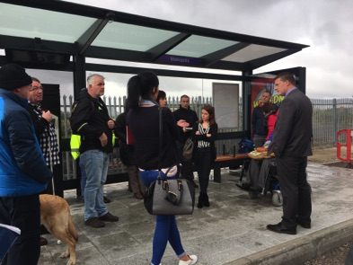

(Image shows disabled people and older people discussing the proposed Glider halt design.)

Glider halts are now being installed across the Belfast routes. Key features of halts include:

  - Each halt will use a specialised bus boarding kerb. This allows the Glider to get close to the kerb reducing any gaps. The height of the kerb reduces steps into and out of Glider.
  - Each halt will include a high quality shelter, providing weather protection.
  - Most shelters will have two types of seating, a perch style seat and a seat with armrests.
  - Most shelters will have additional space suitable for wheelchair and scooter users.
  - Each shelter will have timetable information, a visual display screen with passenger information and CCTV.
  - Seating, ticket machines and validators will be located in the same positions at every halt.
  - Colour contrasting has been used at each halt, including on the footpath, to ensure features are more visible to people with sight loss.

(Image shows the front view of a Glider halt at Millfield in Belfast City Centre.)

Other improvements have been made to ensure easy access to the halts including better quality footpaths and additional Puffin crossings along the route.

The halts are being installed on the existing footpaths on the routes. Imtac is working with the Department for Infrastructure to make sure that disabled people, older people and others don’t experience any problems using the footpaths in and around Glider halts.

Ticketing on Glider

Passengers using Glider need to get a ticket before getting on the vehicle. Passengers will not normally have any contact with the driver.

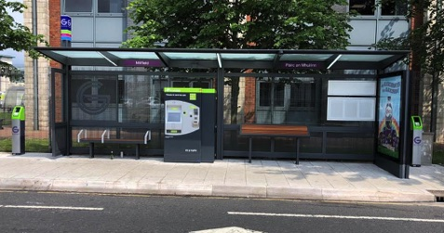
Each halt has a ticket machine for passengers to purchase tickets. Older people and disabled people took part in testing of ticket machines. This testing identified difficulties for some disabled people when using ticket machines. Because of these difficulties the Department for Infrastructure has decided to introduce the following arrangements to help make using Glider easy for disabled people and older people:

  - When Glider launches all Smartpass holders, including free and half-fare holders, can travel free of charge on the service
  - Both free and half-fare Smartpass holders do not need to obtain a ticket or use the ticket machine to use the service.
  - Before getting on Glider Smartpass holders do need to validate their pass

(Image shows a Glider validator. The validator is a stand-alone column located either side of the halt shelters. The top section uses a strong colour to contrast with the base.)

Every halt has two validators that have been designed to be accessible to all users. Validators are located in the same position at every halt, close to either end of the shelter. To use Glider Smartpass holders should touch their pass on the top section of the validator and then board the vehicle. A display screen and an audible signal on the validator will let passengers know their card has been successfully validated.

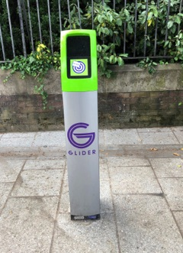
Free travel for Half-fare Smartpass holders only applies on the Glider service. If you use other Metro, Ulsterbus and Northern Ireland Railways services you will have to pay half-fare as normal.

Staff on Glider

Imtac knows how important staff are in making sure it is easy for some disabled people and older people to use public transport. Passengers using Glider will not normally have contact with the driver. There will not always be staff at the Glider halts. There will, however, be staff on Glider routes, called Customer & Revenue Protection Officers. Their job is to assist passengers and make sure everyone using Glider has a ticket.

For Imtac it is very important that these staff can provide appropriate assistance to disabled and older passengers if required. The Committee is currently working with Translink to ensure all staff associated with Glider receives Disability Equality Training, developed and delivered by disabled people.

Other bus services

Glider will replace the majority of Metro bus services that currently operate along these routes. Other services will not be affected and there will be some additional Metro services in east and west Belfast to help communities close to the routes to get to Glider. These services are called feeder services.

Promoting Glider

As it gets closer to the launch of Glider there will be more information for people about how to use the service. Imtac is working with Translink to make sure that information about the service is available to disabled people and older people. This includes developing user guides highlighting the accessible features of the service, available in peoples preferred formats. It also includes developing “how to use” videos for disabled people and older people, including versions with subtitling and audio description.

Getting more information

You can find out more information about Glider from these websites:

http://www.translink.co.uk/also-on-our-site/Glider/

https://www.infrastructure-ni.gov.uk/topics/transport-initiatives/brt-glider

If you would like to apply for a free or half-fare Smartpass you can find out how from this website - https://www.nidirect.gov.uk/information-and-services/bus-and-coach-travel/free-bus-travel-and-concessions.

Imtac will send out information and publish updates about Glider on our website – www.imtac.org.uk.

Alternatively please feel free to contact Michael Lorimer at the Imtac office by telephone/textphone on 028 9072 6020 or by email at info@imtac.org.uk.

