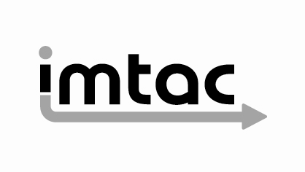

Imtac comments on proposals for 2020 Translink Goldline Vehicle Procurement
(December 2020)

Imtac is committed to making information about our work accessible. Details of how to obtain information in your preferred format are included on the next page.
Making our information accessible

As an organisation of and for disabled people and older people Imtac recognises that the way information is provided can be a barrier to accessing services and participation in public life. We are committed to providing information about our work in formats that best suit the needs of individuals.

All our documents are available in hard copy in 14pt type size as standard. We also provide word and pdf versions of our documents on our website – www.imtac.org.uk. In addition we will provide information in a range of other formats. These formats include:

- Large print
- Audio versions
- Braille
- Electronic copies on disc or via email in PDF or word
- Easy read
- Information about our work in other languages

If you would like this publication in any of the formats listed above or if you have any other information requirements please contact:

Michael Lorimer
Imtac
Titanic Suites
55-59 Adelaide Street
Belfast BT2 8FE

Telephone/Textphone: 028 9072 6020
Email: info@imtac.org.uk
Website: www.imtac.org.uk & www.accessibletravelni.org
Twitter: @ImtacNI

About Imtac

The Inclusive Mobility and Transport Advisory Committee (Imtac) is a committee of disabled people and older people as well as others including key transport professionals. Its role is to advise Government and others in Northern Ireland on issues that affect the mobility of older people and disabled people.

The aim of Imtac is to ensure that disabled people and older people have the same opportunities as everyone else to travel when and where they want.

Imtac receives support from the Department for Infrastructure (herein after referred to as the Department).

Introduction

In November 2020 Imtac was invited by Translink to a site visit to view a new vehicle purchased by the National Transport Authority in Ireland to operate on inter urban rural routes. The site visit allowed the opportunity to view and travel on both the NTA vehicle and a recently purchased high floor Goldline coach. Because of COVID restrictions the site visit was undertaken by the Imtac secretariat, with a follow up remote meeting with Imtac members and members of the Translink Accessibility Working Group held using images and video footage from the site visit.

The Committee notes that the current proposed procurement involves a significant number of vehicles (70 to 80). A separate procurement earlier this year involved the purchase of over 30 high floor coaches, against the advice of Imtac. Taken in the round the two procurements will involve the replacement of the vast majority of current vehicles used to deliver Goldline services and potentially embed the restricted access levels of these services for the next decade. Given this Imtac’s comments must reflect the wider strategic and legal implications of the current procurement proposals as well as the merits or otherwise of each vehicle type. Comments raise important questions for both Translink as the operator of services and the Department as the commissioner of services.

This paper sets out the wider background, legal and policy contexts to the current procurement proposals as well as specific comments on the vehicles inspected on the site visit. The paper concludes with key recommendations for Translink and the Department.

Background

Imtac has been raising its concerns about vehicle procurement policies for a considerable time. Concerns over the purchase of 23 high floor vehicles which replaced low floor vehicles, led the Committee to publish a policy paper in 2013 highlighting the basic barrier to travel for the majority of older people and disabled people (including both wheelchair users and non wheelchair users) created by steps and recommending that all future vehicles purchased using public money be low-floor.

In 2016 Imtac developed a comprehensive paper setting out the incompatibility of high floor vehicles with commitments to inclusive travel given by both Translink and the Department. The paper questioned the legality of current operations, including the 24 hour booking requirement for wheelchair users. Finally the paper highlighted operators running premium commuter services in Great Britain which are run utilising low-floor vehicles. Although shared with both the the Department and Translink, the Committee took the decision not to publish this paper to allow debate about its findings.

Following vehicle procurement proposals in 2018, Imtac published a further paper setting out a series of principles it advised should inform future procurement. The paper again highlighted examples from GB viewed by the Committee as good practice.

It should be noted that despite the public and private concerns expressed by Imtac and its published advice over a period of more than seven years the numbers of high floor vehicles in operation have remained largely the same. Depending on decisions made in the next few weeks this could remain the case until 2030.

Wider context

In considering the detailed specifications of any vehicle procurement it is important to consider the wider legal and strategic policy context. This is particularly true with a procurement that will shape the nature of inter-urban and rural bus travel for the next decade, at a time when Government policy is seeking to encourage everyone to make more sustainable travel choices.

Legal context

There are a number of legal matters that must be considered as part of the decision making process.

Under the general provisions of the Transport Act NI 2011 the Department must have due regard to accessibility in securing the provision of public transport services. This is, in the opinion of Imtac, a significant duty placed upon the Department that goes beyond requiring compliance with minimum legal standards. If the body charged with giving advice to the Department about accessibility has consistently raised concerns about the accessibility of vehicles (purchased using public money), this is a matter the Department is obliged under the Act to take seriously.

Vehicle accessibility standards are set out in the Public Service Vehicle Accessibility Regulations which are enacted under Part 5 of the Disability Discrimination Act. Imtac has never disputed that high floor coaches are permitted under PSVAR and that vehicles purchased by Translink met these technical specifications. However in 2016 the Committee questioned whether 24 hour notice requirements were compliant with the provision within PSVAR for seating in a wheelchair user space to be removed when required by a wheelchair user. Imtac has recently discovered correspondence from DVSA which supports its assessment of the legality of notice requirements (see Appendix A). If, as Imtac now believes to be the case, the notice requirement is unlawful, it must now be removed without delay. The Committee is aware that this creates significant operational headaches for Translink in the short term, but these operational difficulties should also lead to questions over the value of investing in similar vehicles in the future.

One of the operational issues faced by Translink is the deployment of lifts from high floor coaches at bus stops across the network. Appendix B contains photographs taken from Google Maps illustrating accessibility issues at random bus stops used by Goldline services across Northern Ireland. If it is accepted that wheelchair users have the right to use these vehicles without prior notice, it should also be accepted that they have the right to access the infrastructure associated with the services. Part 3 of the DDA (Access to Goods, Facilities and Services) requires physical changes to infrastructure to make a service accessible or for a reasonable adjustment to be made to ensure disabled people do not experience less favourable treatment. The potential of DDA challenges relating to bus infrastructure should be of concern to both the Department and Translink and should again lead to questions over the value of investing in similar vehicles in the future.

As part of the UK the Northern Ireland Government has obligations under the articles of the UN Convention on the Rights of People with Disabilities. Article 9 of the Convention relates to accessibility and requires States to ensure access on equal basis to others for disabled people to transport services (including specifically in rural areas). UNCRPD was a key driver used by disabled people in Ireland in achieving changes resulting in the vehicle design adopted by the NTA. As in Ireland UNCRPD obligations must be something the Department should take careful note of in decisions around the use of public funds.

Policy context

The Programme for Government is an outcome based delivery plan with the aim of improving well being for all, tackling disadvantage and driving economic growth. Easy access to inclusive transport is a key building block in achieving most, if not all, of the 11 outcomes. Continuing to invest in vehicles Government knows many people in society find difficult to use means continued exclusion from access to key services, employment, education and training as well as participation in public life and social and leisure activities. In short it undermines the priorities and goals set by Government in its own PfG.

Both the Department and Translink have made broad, positive strategic commitments to accessibility and inclusion. The draft Delivery Plan for the Programme for Government (PfG) relating to Indicators 23, 25 and 47 gave the commitment “to have a transport network that is inclusive and accessible to all”. Translink have made a similar commitment “to deliver a transport network in Northern Ireland that is inclusive and accessible to all.” Neither can be achieved if we continue to invest in vehicles many find difficult or impossible to use.

Site visit vehicle assessments

Imtac has used its previously published principles to assess and compare the vehicles viewed at the site visit.

1 Following inclusive design principles

Imtac’s advice is that our public transport system, both vehicles and wider infrastructure should be accessible and usable by as many people as possible including disabled people, non-disabled people, people with dependents including carers and people travelling with young children. This is best achieved by using inclusive design principles.

As will be demonstrated below it is unarguable, even under the most basic assessment, that the NTA vehicle is a better example of inclusive design than the high floor Goldline coach.

2 Vehicles must be step free

Imtac’s advice is that step free vehicles work best for the majority of the population and are essential for disabled people, older people and others. This means vehicles should have only one step at the entrance, a ramp for easy boarding and a section of interior with no further steps.

As illustrated by the images below. The NTA vehicle meets Imtac’s requirements in their entirety. The Goldline coach doesn’t meet the requirements, with three steps at the entrance and a further three interior steps. Given that research has proven that large numbers of disabled people and older people find steps a significant barrier, the continued purchase and use of high floor coaches makes routine travel on public transport difficult or impossible for them.

3 All vehicles must have a dedicated priority space for wheelchair users

The NTA vehicle has a dedicated space for wheelchair users in line with Imtac advice. Although access from the vehicle entrance to the space may be limiting for some larger wheelchair users, the majority of wheelchair users should be able to routinely access the vehicle in the majority of locations given the ramped entrance.

Access for wheelchair users to the Goldline coach is via separate lift access, operated by the driver. To enable access, seating must be removed from the space. The operational difficulties of these processes have led to the 24 hour notice requirements. It is welcome that Translink is now proposing removing seating in the wheelchair user space (and removing 24 hour notice). However given the issues with infrastructure highlighted in Appendix B, this measure is unlikely to resolve all operational challenges for Translink and consequently wheelchair users are likely to continue to face travel restrictions due to the vehicles design limitations.

4 All vehicles must provide additional flexible space for other passengers

Neither vehicle has an ideal configuration in terms of additional flexible seating that could be used by the range of different passengers who require additional space (people travelling with assistance dogs, people travelling with prams and buggies, people travelling with bulky mobility equipment and people travelling with luggage). The NTA vehicle does include, however, include dedicated seating for people travelling with young children and a storage space for buggies, demonstrating some thought about designing for different user requirements. The NTA vehicle includes interior luggage storage, Goldline has exterior luggage compartments.

5 Future buses do not include “modesty boards”

Modesty boards are a more common design feature on low-floor buses rather than on coaches. These boards are largely included for aesthetic reasons but can be restrictive in terms of passenger leg room, making journeys uncomfortable for some disabled people and older people.

The NTA does include some modesty boards. However leg room is restricted in the seating provision on both the NTA vehicle and the Goldline coach.

6 Vehicle must provide a full range of accessible design features

Accessible design features considered essential by Imtac for ease of use by disabled people and older people include: frequent provision of hand and grab rails, low level accessible bell pushes, wide aisles and gangways, a minimum of 4 forward facing priority seats and the use of good colour contrasting throughout.

As with other design requirements the NTA vehicle is superior to the Goldline coach. The vehicle has generous provision of hand and grab rails throughout, the Goldline coach has minimal provision after the entrance. The NTA has low level bell pushes at each priority seat, the Goldline has one (in addition to provision in the wheelchair user space). Gangway width is limited in both vehicles but more generous in the low floor section of the NTA vehicle. The NTA vehicle has four priority seats, the Goldline coach only two. Finally contrasting materials are used to good effect on the NTA, not so much on the Goldline coach.

7 Vehicles must include the provision for audio and visual next stop information

It is positive that both vehicles included screens and equipment for the provision of audio and visual information. Once again, however, the NTA vehicle had the edge by providing 2 screens, one close to the entrance and another towards the rear of the vehicle. This is another example of good, inclusive design ensuring passengers have access to screens regardless of where they sit on a vehicle. The screen on the Goldline coach is situated at the entrance to the vehicle is difficult to read for passengers sitting to the rear of the vehicle.

8 Vehicle procurement must address the current service disparity between rural and urban areas

Imtac considers that people living in rural areas should expect equality in accessing public transport services in comparison to their urban counterparts. It should not be acceptable that the design of rural buses is less accessible than urban bus services.

As illustrated above the continued purchase of the Goldline coach design will hardwire physical accessibility barriers into our rural network for the next decade. The NTA vehicle is, from Imtac’s perspective, a significant improvement offering many, but not all, of the features Imtac believe are essential to make bus travel inclusive and accessible.

Operational considerations

In making an overall assessment of vehicles it is only fair to reflect operational concerns expressed by Translink about the NTA vehicle.

These include:

- The poor ride quality of the NTA vehicle compared to the Goldline coach leading to concerns about suitability for travelling long distances
- Reductions in overall capacity and its implications at peak times and overall bus number requirements
- The additional length of the NTA vehicle which will create access and garaging issues at a number of depots
- The lack of a rear steer on the NTA vehicles, creating issues with manoeuvrability

The Committee recognises that operational issues are an important consideration in assessing the practical suitability of vehicles but these should be balanced against the operational issues (particularly around accessibility) presented by high floor coaches.

Conclusions and recommendations

Imtac obviously shares the aspiration of both the Department and Translink for an inclusive public transport system accessible to all. The Committee, however, cannot be clearer in its advice that this cannot be achieved whilst we continue to purchase high floor vehicles with inherent physical design barriers that make access difficult or impossible for many disabled people (both wheelchair users and non wheelchair users), older people and others.

It is also incumbent on the Committee to point out the significant potential legal difficulties the continued operation of this type of vehicle will create. The advice of Imtac is that current 24 hour notice requirements on the use of this type of vehicle is unlawful and must be removed without delay. The Committee is aware of the operational challenges this will create for Translink, given accessibility issues across the bus network but the continued long term use of high floor vehicles is likely to result in significant legal challenge from disabled people.

Based on both a strategic policy and legal considerations Imtac has no alternative other than to recommend that future vehicle purchases funded by the Department should be low-floor only. The Committee recognises that the move away from high floor vehicles will represent a significant change in culture for both Translink and current passengers. However there are plenty of examples of operators in Great Britain that run successful, high quality, premium bus services using a variety of low-floor vehicle types.

The Committee acknowledges there are legitimate operational concerns about the NTA vehicle in particular and the suitability of other low-floor vehicles for longer distance travel. Given these concerns the Committee recommends that future vehicle procurement reflect operational variations to include:

- New design of high quality low-floor double deck buses on shorter Goldline routes (1.5 hours or less)
- Use of existing low-floor double deck coach design on longer Goldline routes (in excess of 1.5 hours)
- Continued monitoring of vehicle design concepts with a view to identifying solutions that better balance operational and accessibility requirements

In line with Imtac’s advice it recommends further consultation and agreement on the detailed design specification for each vehicle type embedding inclusive design principles to the process. The Committee believes this process will have significant benefits for Translink as an operator by making services more attractive to a wider passenger market. Glider provides the obvious example locally of the benefits of this process.

The Committee recognises that the operation of double deck vehicles is not possible on some routes due to issues such as low bridges. Recent procurement of new high floor single deck coaches does mean that these vehicles will continue to be available to operate along these routes. The life span of these vehicles should allow time to identify better future inclusive vehicle solutions for these routes.

As significant numbers of high floor coaches will continue to be used on services careful consideration needs to be given to how these can be used to ensure disabled people can travel on a equal basis to others. The removal of the 24 hours notice requirement and the removal of seating in the wheelchair users space are welcome and essential steps towards improving current provision. Significant work is also required in identifying and undertaking improvements required to bus infrastructure and alternative reasonable adjustments where this not possible.

Imtac would like to thank the Department and Translink for the opportunity to contribute to current discussions around vehicle procurement. The Committee recognise the significant challenge changes in current cultures and practices can represent but argue that because of the potential size of the current procurement, the potential legal and strategic policy challenges, some options throw up, now is the time to implement a change in direction. The fully acknowledge and welcome the significant positive steps taken by both Translink and the Department to improve the accessibility of public transport but without a change in direction now many parts of the network are likely to remain inaccessible to older people, disabled people and others until 2030 and beyond.
Appendix A - DVSA correspondence of the rights of wheelchair users when accessing coaches


11 July 2018
Coach operators reminded of the rights of passengers who use wheelchairs
Coach operators will face tough action if they don’t comply with the law on the use of wheelchairs in vehicles, warned the Driver and Vehicle Standards Agency (DVSA) today (11 July 2018).
The key requirements are:
- to ensure that wheelchair users can use available* wheelchair spaces, including those that require the removal, folding or tipping of other seats; and
- not to require passengers who use wheelchairs to book any further in advance than passengers who don’t.
Simply put, if a wheelchair space is available wheelchair users must be able to use it, even if they buy a ticket on the day. Coach operators should ensure all their staff – from drivers to ticketing and contact centre staff - know the law too.
DVSA will not hesitate in investigating and reporting breaches to the traffic commissioners, who will then decide whether there are grounds for further action. The agency is currently investigating 3 companies who appear to have broken the rules.
Transport Accessibility Minister Nusrat Ghani said:
“How people travel should not be limited by their impairments. It is essential that the transport system is accessible and works for everyone, including those who use wheelchairs.
“The department recently announced its intention to support better access to spaces for wheelchair users so they can travel where they like and with confidence.”
Gareth Llewelyn DVSA Chief Executive said:
“DVSA’s priority is to protect the public from unsafe drivers and vehicles. We know the majority of coach operators, and their drivers and other staff, work hard to provide professional services. But there also appears to be some confusion in the industry.
“We’re currently investigating a number of cases where drivers, ticketing staff and even coach company call centres seem to be unaware of the law. So we’re working with the Confederation of Passenger Transport to put the record straight.”
Coach companies can advise or recommend that wheelchair-using passengers book seats in advance but drivers and other staff cannot require it as a condition of travel. If the wheelchair space is available – including spaces where seats have to be removed, tipped or folded – coach companies must allow a wheelchair user to occupy it, even if they turn up and buy a ticket on the day.
The only exceptions are:
- Some coaches are not required to have wheelchair spaces until 1 January 2020;
- If a service is completely full, existing passengers are not required to disembark to allow the wheelchair space to be used, but if it’s not the driver should ask other passengers who do not have a legitimate need of the wheelchair space to move to alternative seats.
Further information:
- Available means that the coach is not full, that the wheelchair space is not occupied by someone using a wheelchair or that it has not been booked by someone using a wheelchair for all or part of the same journey.
Appendix B - Examples of bus stop infrastructure

1 Church Street, Ballynahinch

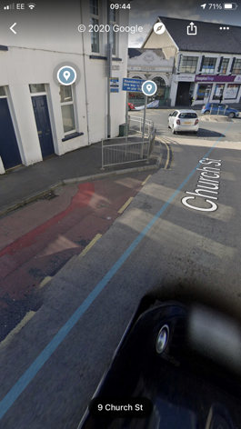
The picture shows a bus stop in Ballynahinch town centre served by Goldline coaches travelling between Newcastle and Belfast. Footway space is limited with no room to deploy a lift but a ramp from a low-floor vehicle could be deployed.

2 Antrim Road (Ballymena)

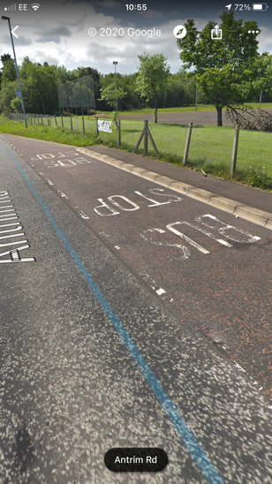
Picture shows a bus stop on the Antrim Road, Ballymena, served by Goldline coaches operating between Ballymena, Coleraine and Belfast. The footway is extremely narrow (less than 2m) with insufficient width to deploy a passenger lift. The lack of footway width would also make safe ramp access difficult.

3 Dromore town centre

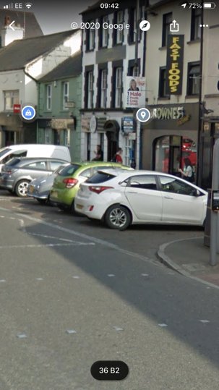
The picture shows the bus stop for Goldline services heading from Belfast to Newry in Dromore. There is no hard surface for the deployment of a ramp or lift due to on street parking. This situation will hopefully be improved through a current public realm but is indicative problems with existing infrastructure in some locations.
4 Moy Road, Dungannon

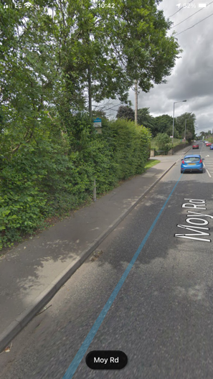
The picture shows a bus stop served by Goldline coaches on the Moy Road, Dungannon. Footway width is minimal, reduced by encroaching hedging. There is insufficient width to deploy a passenger lift but a ramp could be deployed.

https://www.imtac.org.uk/sites/imtac/files/media-files/stepfreetransport%20%28finalversion%29.pdf
https://www.imtac.org.uk/sites/imtac/files/media-files/Bus%20Paper%20%28Final%20Version%20April%2018%29.pdf
https://www.legislation.gov.uk/nia/2011/11/section/1
https://www.legislation.gov.uk/nisr/2003/37/contents/made

