Evaluating the impact of the introduction of pavement café licensing on the mobility of disabled people and older people in Northern Ireland

(December 2018)

Imtac is committed to making information about our work accessible. Details of how to obtain information in your preferred format are included on the next page.

Making our information accessible

As an organisation of and for disabled people and older people Imtac recognises that the way information is provided can be a barrier to accessing services and participation in public life. We are committed to providing information about our work in formats that best suit the needs of individuals.

All our documents are available in hard copy in 14pt type size as standard. We also provide word and pdf versions of our documents on our website – www.imtac.org.uk. In addition we will provide information in a range of other formats. These formats include:

- Large print
- Audio cassette or CD
- Daisy disc
- Braille
- Electronic copies on disc or via email in PDF or word
- Easy read
- Information about our work in other languages

If you would like this publication in any of the formats listed above or if you have any other information requirements please contact:

Michael Lorimer
Imtac
Titanic Suites
55-59 Adelaide Street
Belfast BT2 8FE

Telephone/Textphone: 028 9072 6020
Email: info@imtac.org.uk

Website: www.imtac.org.uk
Twitter: @ImtacNI
About Imtac

The Inclusive Mobility and Transport Advisory Committee (Imtac) is a committee of disabled people and older people as well as others including key transport professionals. Its role is to advise Government and others in Northern Ireland on issues that affect the mobility of older people and disabled people.

The aim of the Committee is to ensure that older people and disabled people have the same opportunities as everyone else to travel when and where they want.

Imtac receives support from the Department for Infrastructure.

Introduction

This report examines the development and introduction of pavement café licensing in Northern Ireland including early consultation on proposals, the legislative process, the subsequent development of guidance and the response of local councils since the introduction of licensing in October 2016. The report also looks at pavement café provision in a number of towns and cities across Northern Ireland following audits undertaken by Imtac in 2018. Finally, based on the above, the report provides an evaluation of the impact licensing has had on the lives of older people and disabled people and makes recommendations for improvement.

Development and introduction of pavement café licensing

Early consultation

The Department for Social Development (DSD) published a consultation on proposals for pavement café licensing in late 2010. In its response Imtac welcomed in principle the introduction of regulation but raised concerns that proposals did not fully acknowledge the negative impact pavement cafes can have on the mobility of older people, disabled people and other pedestrians, recommending an Equality Impact Assessment (EQIA) be undertaken in advance of proposed legislation.

Subsequently Imtac published a more detailed position paper outlining its views of pavement café licensing. The paper made 13 separate recommendations designed to ensure that regulation would protect access for all pedestrians using the footway. These recommendations were based on accepted inclusive design guidance, good practice identified from the licensing of pavement cafes in Great Britain and existing equality duties and legislation. Two important recommendations were maintaining an unobstructed clear footway of at least 2m around cafes and ensuring that all cafes had suitable screening on all sides.

The legislative process

Imtac made a significant contribution to the legislative process including submitting a written response to a Call for Evidence from the Committee for Social Development and a subsequent oral evidence session in front of the Committee. Based the recommendations in its position paper Imtac requested the legislation explicitly include a requirement to protect pedestrians and the need to consider access for disabled people and older people in particular. This approach was supported by other organisations including Disability Action and Guide Dogs.

Unfortunately The Licensing of Pavement Cafés Act (Northern Ireland) 2014 makes no specific reference to access requirements. Under its provisions councils can refuse an application where it “would be likely to result in undue interference or inconvenience to persons or vehicles in the vicinity….” In response to concerns raised by Imtac and others the then Minister for Social Development stated access requirements would be addressed during the development of guidance by DSD and councils and gave explicit assurances on the floor of the Assembly and in writing to the Committee for Social Development to “place strong emphasis on putting the access needs of pedestrians at the heart of the licensing regime.”

The development of Departmental guidance

Imtac was approached by DSD officials for feedback on its draft guidance in early 2015. The guidance was designed to be used by councils when making decisions about pavement café licence applications. Imtac organised a meeting with officials, Imtac members and representatives of Disability Action, Guide Dogs and RNIB, held on the 18th February 2015. Following the meeting formal comments, reflecting collective issues for all organisations, were submitted to the DSD with recommended changes. These changes included requiring a minimum of 2m unobstructed footway width around cafes and for cafes to be screened on all sides. In its subsequent response the DSD accepted some minor recommendations but rejected the inclusion of specific guidance around footway widths and screening claiming “the Assembly took the view that all final decisions on general layout/minimum width should be made by councils on an individual application basis.”

Following engagement with officials from the DSD Imtac members met with both the then Minister for Social Development and the Committee for Social Development to voice concerns about the draft guidance. Despite this the DSD subsequently published its guidance without further amendment. Section 4 contains information about size and location of cafes stating “The overriding premise is that the needs of users of the pavement are paramount and shall not be compromised...”. However guidance goes on to say “The Act does not specify minimum standards in terms of the size, layout or design of a pavement café. District councils are best placed to make these decisions on a site by site basis, taking account of the characteristics of the site, the space available and the proposed layout of the café area.” The guidance also quotes Transport NI (now DfI Roads) guidance which states that whilst 2m clear footway is desirable, this can be reduced to 1.5m where circumstances permit. A width of 1m can only be allowed if there are single point obstructions. The Guide also states cafes “should always be enclosed by way of adequate screening, where practicable”. Following a request from Imtac the DSD confirmed the guidance had not been subject to screening for equality impact.

Engagement with local councils and DfI Roads

Once the DSD had finalised its guidance the onus fell to each council to develop its own guidance. The legislation also places a statutory duty on councils to consult with DfI Roads before making decisions about applications. Since 2016 Imtac has been engaging with both councils and DfI Roads. An initial meeting was held through the Licensing Forum in June 2016, attended by Imtac members, Disability Action, RNIB, Guide Dogs as well as other stakeholders including local councils, DfI Roads and Hospitability Ulster. Subsequent meetings were held with DfI Roads officials and individual councils. It was clear from these initial meetings that there was limited room for compromise on issues such as pavement widths or screening. Councils, DfI Roads and Hospitability Ulster insisted on the need for flexibility to meet local circumstances whilst Imtac and others insisted on the need for clear and consistent standards in every location to ensure access for all pedestrians is maintained.

In May 2017 DfI Roads shared with Imtac its own draft guidance around highway considerations and the design and locations of pavement cafes. Once again differences were apparent between what Imtac and DfI Roads viewed as a safe and accessible pedestrian environment. These differences persisted despite a follow up meeting between Imtac members and council and DfI Roads officials in October 2017. Imtac submitted formal comments to a further draft of the guidance in January 2018. In its response to these comments DfI Roads has maintained its stance that reducing footway width to as little as 1m to accommodate pavement cafes is acceptable and justifiable using the existing inclusive design guidance used by DfI even though this clearly states that “a width of 1.0m should only be allowed if there are single point obstructions”.

Engagement with the Equality Commission for Northern Ireland

Throughout its engagement with Departments and local councils, Imtac has stressed the importance and relevance of statutory equality duties relating to disabled people, older people and others. Newry, Mourne and Down District Council were the first to issue draft guidance. Initially Imtac sought to work with the Council to amend the guidance to better reflect accepted guidance on footway widths for accessibility and its equality screening of the policy. Although the Council made some changes to both documents it retained the option of reducing pavement widths below 2m in unspecified circumstances and failed to acknowledge this potentially would have a major negative impact on the mobility of disabled people, older people and people with dependents. Following discussions with the Equality Commission, the Committee submitted a complaint to the Commission in September 2017 that the Council had failed to meet the requirements of its Equality Scheme under Section 75 of the Northern Ireland Act 1998. The Commission responded to the complaint in May 2018, finding that by making some changes the Council had met its commitments under its Equality Scheme.

Imtac has subsequently discovered that the Equality Commission itself actively encourages businesses to provide seating on the pavement with only 1.5m clear pavement width under its Every Customer Counts campaign. It is worth noting the Equality Commission guidance was published prior to the introduction of the regulation of pavement cafes in Northern Ireland and at a time when placing furniture on the pavement was unlawful.

The response of councils in Northern Ireland to pavement café licensing

In preparing this report Imtac approached each of the 11 councils in Northern Ireland to ascertain the current situation regarding the licensing of pavement cafes. Only three councils have published guidance and application forms - Ards and North Down, Newry, Mourne and Down and East Antrim and Newtownabbey. These councils published guidance allow for reductions in pavement widths to under 2m and flexibility around screening.

Under Freedom of Information Imtac asked each council for the numbers of licenses issued and for how many times enforcement powers have been used since powers were introduced in 2016. As of July 2018 only 2 councils have issued any licenses - Ards and North Down (20) and East Antrim and Newtownabbey (12). None of the councils have undertaken any enforcement action since 2016.

Audits of pavement café provision in town and cities in Northern Ireland

Background

To inform this assessment of the impact of Pavement Café Licensing a number of audits of pavement café provision were undertaken by Imtac in locations across Northern Ireland. The audits took place from January to May 2018 and looked at the overall numbers of cafes in the town or city, whether full screening, partial screening or no screening was provided and whether or not the positioning of the café was likely to impact on the accessibility of the footway. Photographs were taken of good and poor provision and examples are provided in Appendix A.

Overall findings

In total eight locations were surveyed – Belfast City Centre, Armagh, Ballymena, Bangor, Derry, Lisburn, Newcastle and Newry. In total 158 pavement cafes were counted in all the locations with a significant variation in numbers of cafes between each location. Belfast accounted for the most with 80 cafes, Ballymena the least with only 4. As the audits were completed during the earliest and coldest months of the year it is perhaps reasonable to assume that numbers of pavement cafes will increase at other times of the year.

In relation to screening 99 (or 62%) of the cafés had no screening at all, only 20% were fully screened with the remainder only partial screened with exposed seating and tables extending into the footway and likely to cause a potential hazard and obstruction for some pedestrians.

Whilst there are examples in each location of broad footways which are ideal for café culture, there are also many examples of footways where the provision of pavement cafes obstructs and narrows footways to an unacceptable degree. There are also examples of cafés positioned on or close to pedestrian crossings and other important infrastructure such as bus stops creating obstructions and an unsafe environment for all pedestrians.

Three significant points arise from the audits:

- Some of the audits, including Belfast, took place during the coldest weather conditions experienced in Northern Ireland for some time. The fact that pavement café provision was largely unaffected reinforces the point that many of these facilities are provided all year round, not just when the sun shines and it is warm.

- Linked to the above, some cafés provided very limited provision, a screened area with no tables or chairs or with a bench with no tables, outside their premises. One possible explanation for both of the above is that outdoor seating for large parts of the year is provided mainly for the benefit of smokers rather than drinking or eating outdoors.

- A-Boards on the footway, some associated with the cafés, are a major issue in all the locations surveyed. The size, number and positioning of A-Boards create multiple hazards for pedestrians in all locations surveyed.

Findings by location

Belfast City Centre

The audit in Belfast covered the same central streets surveyed in previous work undertaken by Imtac around Blue Badge usage. In total 80 pavement cafés were counted. Of these 44 (55%) were not screened. Only 22 (27%) were screened appropriately on all sides and 14 were only partially screened. Although many locations surveyed were suitable for café culture the failure to provide suitable screening means that these cafés remain a potential hazard for some pedestrians.

There are many examples of pavement café provision in Belfast City Centre where they are likely to impact on accessibility for pedestrians. This is due to a lack of footway width where the café either partially or in some cases completely blocks the footway. There are a number of other locations, such as Donegall Square West where the large numbers of pedestrians and bus passengers on the footway mean pavement cafes create obvious obstructions and hazards. Finally there are a number of locations in the City Centre where pavement cafés obstruct pedestrian crossings, blocking important tactile paving. This represents a significant danger to pedestrians with sight loss in particular.

Armagh

The main streets in the centre of Armagh were surveyed. Generally due to the historic nature of the city footways in the city centre are narrow and not ideally suited to outdoor seating.

In total 9 pavement cafés were counted. Of these 3 were screened appropriately with the remaining 6 unscreened. There were some examples of cafés positioned away from the main pedestrian desire lines. However there were other examples were both screened and unscreened cafes narrowed footways to unacceptable level, particularly when accompanied by other street clutter such as A-Boards and bins.

Ballymena

Ballymena town centre had only 4 pavement cafés on the day of the survey. Two were unscreened, although one of the unscreened cafes was located away from the main pedestrian desire line. Despite this unscreened cafes represent a potential hazard for any pedestrian with a visual impairment.

Bangor

A total of 9 pavement cafes were counted in Bangor town centre on the day of the survey. Of these 5 were unscreened, 1 screened appropriately with the remaining 3 only partially screened. Two additional issues of note arise from the Bangor survey. Firstly A-Boards associated with cafés, positioned outside the café boundaries create additional potential hazards for pedestrians in the town. Secondly two cafes in the town are positioned beside a controlled crossing and obstruct tactile paving.

Derry/Londonderry

The main streets in the centre of Derry were surveyed. Due to its historic nature many of the footways in the city are narrow and unsuited to pavement cafés.

In total 10 pavement cafés were counted in the city during the audit. Of these only 1 was screened appropriately, 7 were unscreened and 2 only partially screened. In one location the café has been located away from the main pedestrian route, minimising potential for obstruction. As with other locations multiple A-Boards on the footway are a major additional potential hazard for pedestrians.

Lisburn

In total 12 pavement cafés were counted during the audit of Lisburn city centre. Of these only 1 was appropriately screened 9 were unscreened, and 2 partially screened.

There are a number of places in the city centre, including the pedestrianised Bow Street, which lends themselves to café culture. However none of the cafés in this street were screened. Other locations, such as Haslem’s Lane, are too narrow and completely unsuited to any outdoor seating. In one location the area was appropriately screened but no tables or seating provided. This area was clearly designed for the use of smokers and is not a pavement cafe.

Newcastle

As a busy seaside resort, Newcastle contained more pavement cafes, 21, than any other location other than Belfast. Of these 14 (66%) were unscreened, 4 appropriately screened and 2 only partially screened.

As with other locations there are some areas of the town suitable for café culture, however the lack of screening in most locations creates hazards for pedestrians. As with other locations, the use of large A-Boards, often associated with the café concerned, further impacts on the accessibility of the footways. Finally there are locations in the town where the lack of footway width means it is an unsuitable place to locate a pavement café, particularly given the high footfall in summer months.

Newry

Newry City Centre contains many streets with narrow footways unsuited to café culture. In total 13 pavement cafés were counted during the survey. None were appropriately screened. Only 1 was partially screened, with the remaining 12 unscreened.

In some locations efforts had been made to minimise the impact of the café by locating seating and chairs in recesses associated with the shop frontage. However in a number of locations tables and chairs obstructed narrow footways partially or completely. A number of cafés provided benches but no tables for customers outside their premises. Whilst this reduces potential obstruction it does suggest that the facility is provided for smokers not people eating or drinking outside and is not therefore a pavement.

Evaluating the impact of pavement café licensing

From any objective analysis it is clear that the current approach to pavement café licensing is not working. At the most basic level the fact that only 2 councils have issued licenses and that only 32 such licenses in total have been issued since 2016 shows the current approach is not working. The audits undertaken by Imtac together with information gathered from councils illustrates that the provision of pavement cafes continues unregulated in many locations in Northern Ireland with no application of any standards around access for pedestrians. Furthermore there is some indication that in certain locations such as Belfast the numbers of cafes has increased significantly. Finally it would appear from the audits that pavement café licensing may also have resulted in a permissive culture for other unregulated pavement clutter, notably smoking areas and advertising boards (A-Boards). The continued lack of regulation of pavement cafes and the increasing amount of other clutter on footways is creating a hostile environment for many older and disabled pedestrians and is, in the opinion of Imtac, having a major detrimental impact of the lives of older people and disabled people.

Clearly a major part of the reason for the inertia and lack of progress in implementing pavement café licensing has been the inability of the statutory agencies involved to devise and publish inclusive design guidance which maintains acceptable levels of accessibility for everyone. Any evaluation of the current situation must look in detail at the reasons for this in particular.

A major weakness in the approach adopted to date to access requirements by the Department for Social Development , local councils and DfI Roads is as a result of the conflicting and contradictory political aspirations for licensing set during the legislative process. On the one hand the legislation sets an objective for a light touch regulatory approach where councils can adapt to local circumstances and differing requirements of businesses. On the other hand Ministerial statements made clear that access for pedestrians, and for disabled people in particular, was a essential component of the new licensing regime. It is clear to Imtac that these two approaches are mutually exclusive and have created a situation where the agencies involved have found it impossible to deliver both priorities. Fundamentally we cannot have a liberal, flexible licensing regime and at the same time ensure the strict access requirements needed by pedestrians are in place.

In attempting to square this circle all agencies involved have tried to use selective elements of inclusive design guidance to justify reducing accessibility requirements. Imtac would like to make clear that there is no justification for this approach. Appendix B includes the full text of the relevant part of Inclusive Mobility which has been adopted as guidance throughout the UK. It is clear that the design guidance sees 2m as the minimum acceptable pavement width for pedestrian comfort and access. In the busiest areas, such as around cafes, the design guidance recommends extending pavement widths. Only where “physical constraints” exist does guidance permit reductions in pavement width below 2m. Any reasonable assessment of the guidance must conclude that a barrier purposely created by an individual business or for that matter a Government policy cannot and should not be considered a physical constraint. If standards are to be used and quoted as justification it is essential that they are used correctly and in the spirit in which they are written.

The approach to date has also shown a lack of understanding of whom disabled people are and their rights. Other parts of Inclusive Mobility focus on the basic and different access requirements of disabled people with a range of impairments, including the pavement width required by different users. Even a cursory reading of this information illustrates the significant and negative impact reducing pavement widths to accommodate pavement cafes will have on the lives of disabled people. To be clear disabled people live in all parts of Northern Ireland and cannot vary their impairment to meet local circumstances. A pavement café licensing regime that allows councils to make decisions based on local circumstances largely ignores these universal basic human factors and cannot fail to impact negatively on disabled people.

Government in Northern Ireland has national and international legal obligations to ensure the rights of disabled people are incorporated into the design of new policies. In the opinion of Imtac a policy that results in narrower footways directly contravenes at least two articles of the UN Convention on the Rights of People with Disabilities (UNCRPD) – Article 9 Accessibility and Article 19 Independent Living and Being Included in the Community. In addition public bodies have statutory equality and disability duties to promote the participation of disabled people in public, promote positive attitudes towards disabled people and ensure policies do not negatively impact on disabled people and others. These legal responsibilities and obligations must be given priority over the requirements of individual businesses.

Throughout the development and implementation of pavement café licensing Imtac members have been frustrated and disappointed by the lack of regard shown by all agencies to lived experiences of disabled people and the direct, negative and obvious impact on their daily lives created by obstructions on footways. Imtac has repeatedly asked for evidence from the agencies that reducing pavement widths below minimum requirements specified by design guidance is safe and accessible but is yet to receive any. Perhaps most disappointing of all was the discovery that the body charged with promoting and enforcing the rights of disabled people actively encourages service providers to narrow pavements.

Conclusion and recommendations

It is difficult to avoid the conclusion that little positive has emerged for disabled people or older people from an evaluation of the introduction of licensing of pavement cafes. Despite assurances that pedestrians would be at the heart of the new licensing regime, the desire to provide light touch regulation that benefits businesses has been pushed to the fore. Imtac is concerned that the inevitable result has been the inability of all the agencies involved to agree on a way forward that meets the accessibility requirements of everyone and has led to an impasse where the vast majority of councils are undertaking no licensing whatsoever. For the most part pavement cafes remain unregulated and in many cases a major hazard to older people and disabled people in locations across Northern Ireland. In addition there is a suggestion from surveys undertaken by Imtac that both the unregulated provision of pavement cafes and other clutter on footways has increased since the introduction of licensing.

The Committee believes a rethink of the current situation is overdue and would welcome the opportunity to engage collectively with the Departments involved, local councils and the Equality Commission. Discussions should focus on how best to accommodate the requirements of business within the context of disabled people’s rights and existing equality obligations, inclusive design guidance and existing Ministerial commitments designed to ensure pedestrians are at the heart of any licensing regime.

Appendix A – Images from audits of pavement café provision in towns and cities across Northern Ireland
Belfast

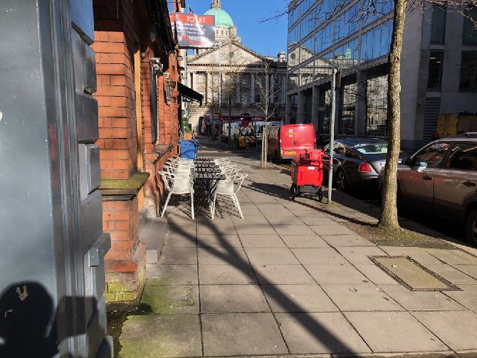
An unscreened pavement cafe on Linenhall Street creates a potential hazard.
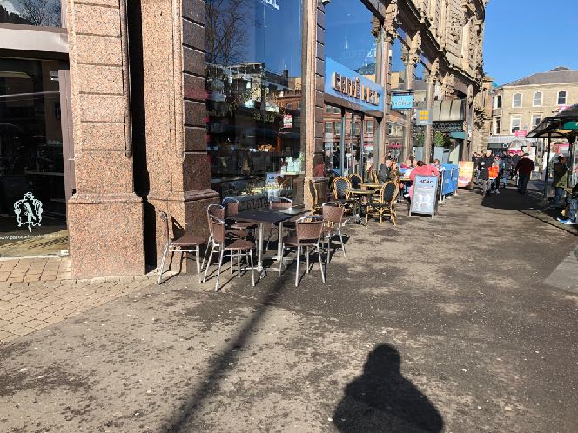
A series of partially screened and unscreened pavement cafes create hazards and obstructions on a very busy footway on Donegall Square West.
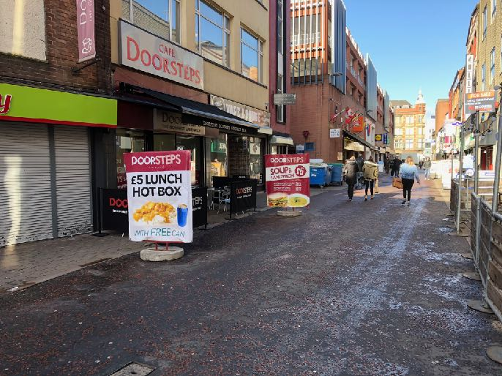
A pavement cafe on Chapel Lane is well screened. Two large A-Boards associated with the cafe create unnecessary hazards.

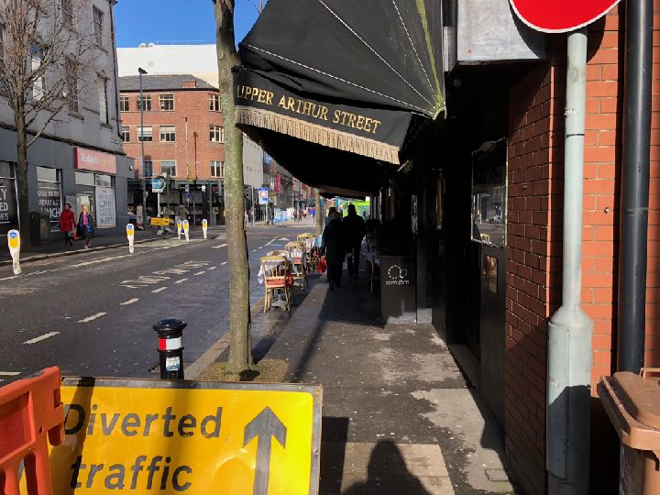
An unscreened pavement cafe on Upper Arthur Street obstructs an already narrow footway leaving only a narrow space for pedestrians between tables and chairs.

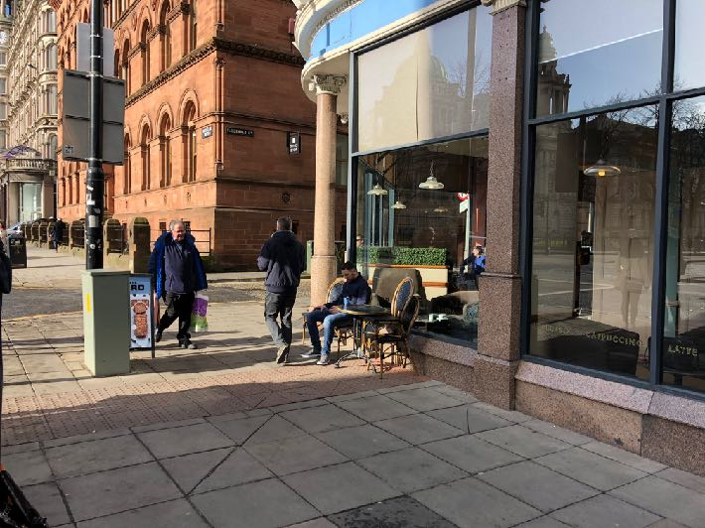
Unscreened tables and chairs associated with a pavement cafe on Chichester Street obstruct a controlled crossing. An A-Board associated with the cafe creates an additional hazard.
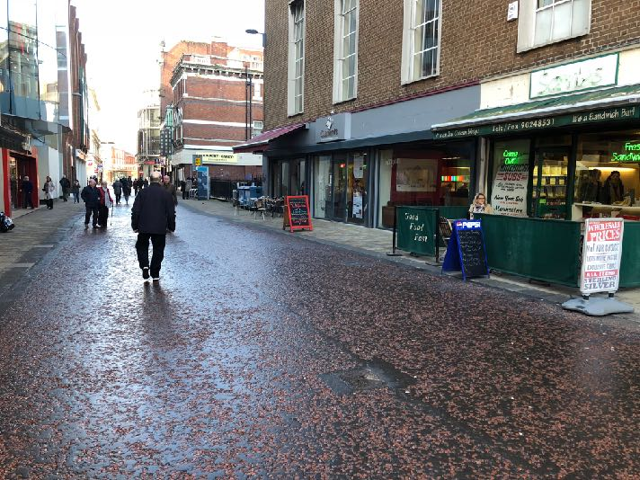
Two pavement cafes on Rosemary Street, one is appropriately screened the other is unscreened. Both cafes have associated A-Boards which create an additional hazard

Armagh

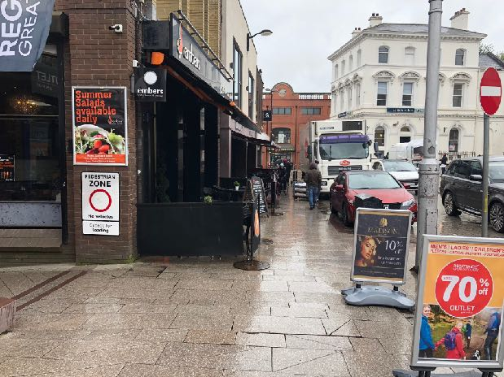
A series of pavement cafes, A-Board and other clutter create potential hazards around the Market Place. Although partially screened the width of unobstructed footway is an issue.
Ballymena
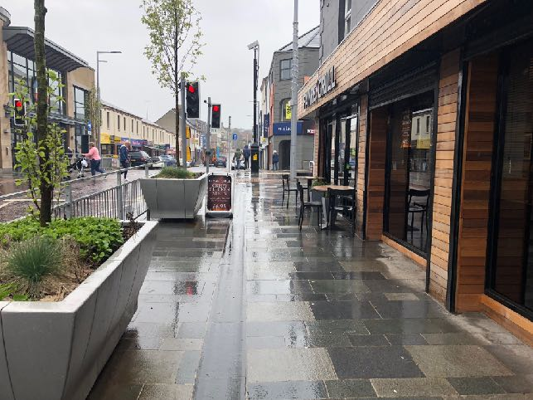
Unscreened tables and chairs and an associated A-Board create hazards on the footway on Wellington Street.
Bangor

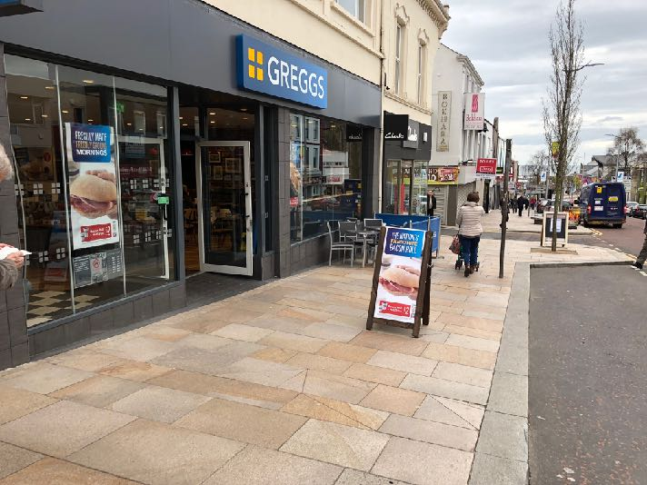
This pavement cafe on Main Street is only partially screened presenting a hazard for people with a visual impairment. A large A-Board associated with the business creates an additional obstruction on the footway.
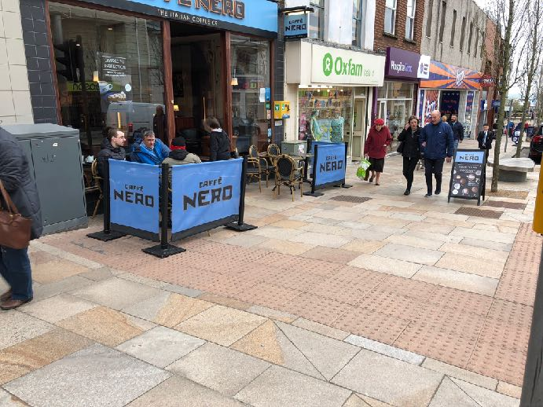
A pavement cafe further along Main Street has a good example of screening. However the cafe is located on the tactile tail of a controlled crossing and an A-Board obstructs the footway.
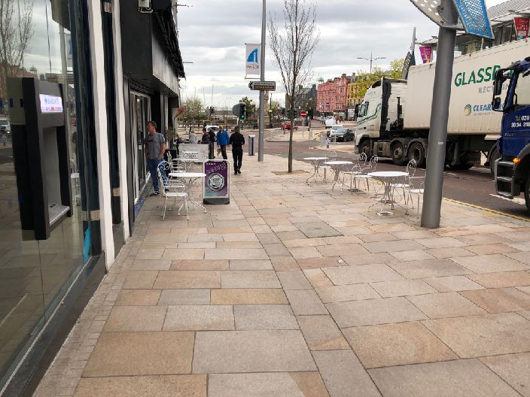
Another pavement cafe on Main Street has unscreened table and chairs and an A-Board obstructing the footway and creating a potential hazard for people with a visual impairment.
Derry/Londonderry

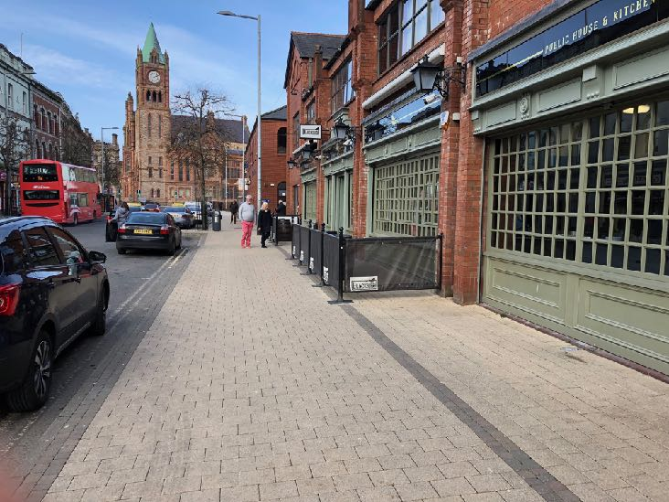
There is a good example of a screened outdoor seating area outside a public house on Foyle Street.
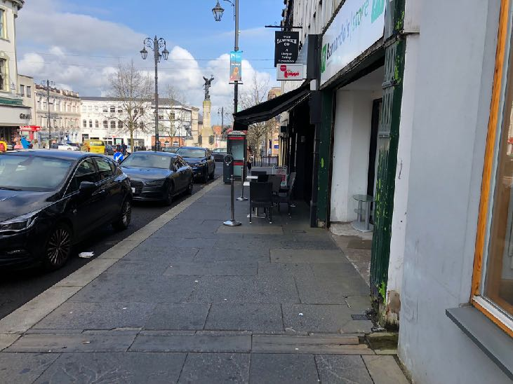
A pavement cafe on Bishop Street is unscreened, leaving little space for pedestrians on the footway.

Lisburn
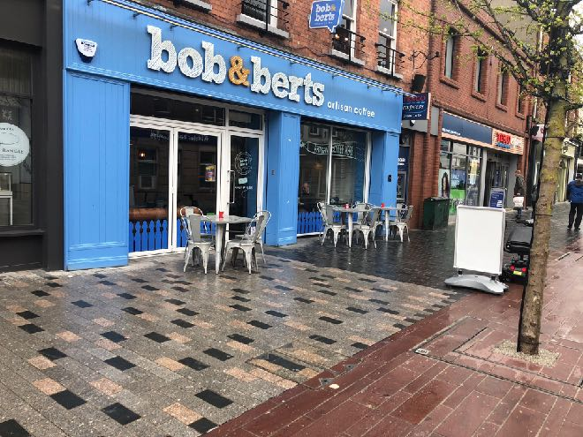
An unscreened pavement cafe and an A-Board on Bow Street create potential hazards for people with a visual impairment.
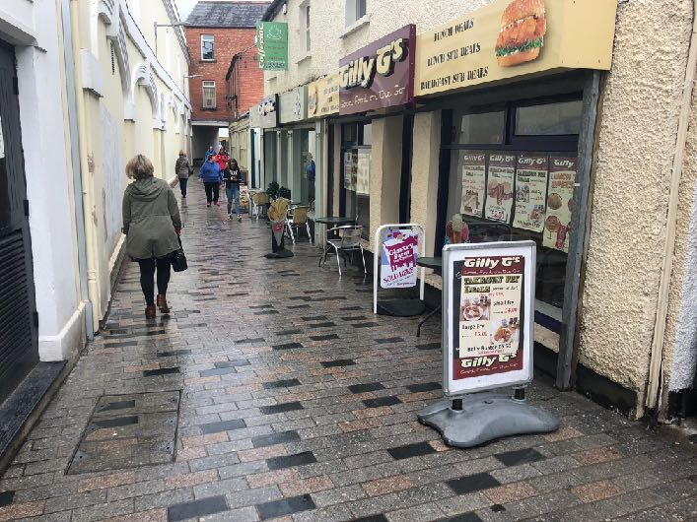
Unscreened tables and chairs along with A-Boards create multiple potential hazards on the already narrow Haslem’s Lane.

Newry

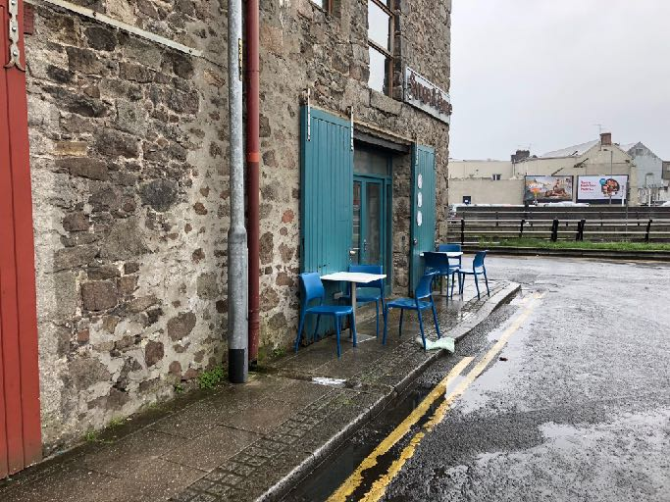
Many footways in Newry are narrow. This pavement cafe on Basin Quay completely obstructs the footway forcing pedestrians onto the carriageway.
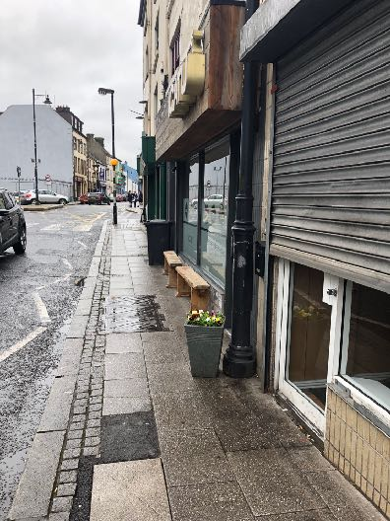
Benches rather than tables and chairs are provided outside a number of premises in Newry including this example on Sugar Island.
Newcastle

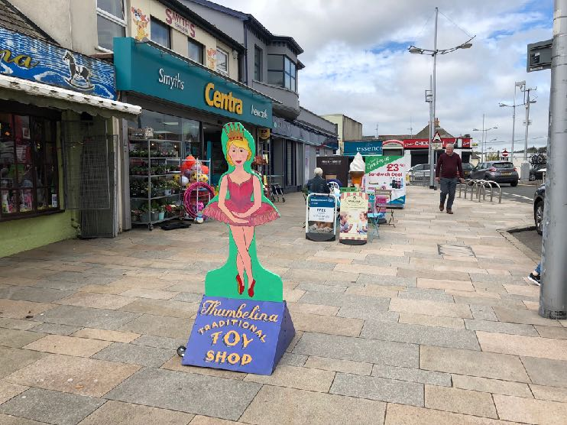
Tables, chairs, A-Boards and other clutter outside a convenience store on Railway Street obstruct the footway and create multiple hazards.
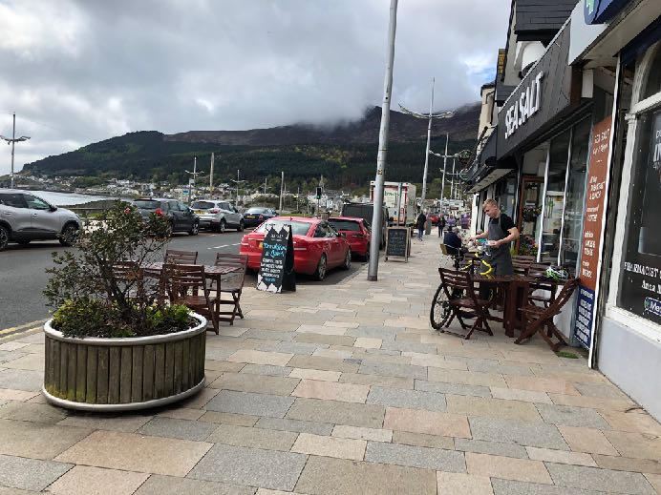
A series of unscreened pavement cafes with A-Boards obstructs the footway a long Main Street.
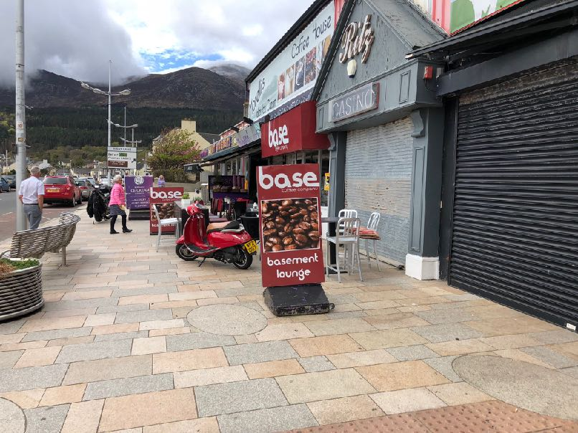
Further along Main Street the footway is completely obstructed by pavement cafes, large A-Boards and parked motorcycles.

Appendix B – Inclusive Mobility (paragraph 3.1) footway widths

3.1 Widths

A clear width of 2000mm allows two wheelchairs to pass one another comfortably. This should be regarded as the minimum under normal circumstances. Where this is not possible because of physical constraints 1500mm could be regarded as the minimum acceptable under most circumstances, giving sufficient space for a wheelchair user and a walker to pass one another. The absolute minimum, where there is an obstacle, should be 1000mm clear space. The maximum length of restricted width should be 6 metres (see also Section 8.3). If there are local restrictions or obstacles causing this sort of reduction in width they should be grouped in a logical and regular pattern to assist visually impaired people.

It is also recommended that there should be minimum widths of 3000mm at bus stops and 3500mm to 4500mm by shops though it is recognized that available space will not always be sufficient to achieve these dimensions.

Where a cycle track runs alongside a footway or a footpath best practice is to physically segregate the two as advocated in Local Transport Note (LTN) 2/86 Shared Use by Cyclists and Pedestrians.

If this is not possible, appropriate tactile surfaces should be used to identify the cycle and pedestrian paths (see Section 4.5). The cycle track should be at least 1400mm wide with the cycle symbol on the ground every 50 yards. The pedestrian part should meet the standards given earlier in this section and should be separated from the cycle track by a raised dividing line 150mm wide and 12 to 20mm high, with a 50mm wide top face.

https://www.imtac.org.uk/publications/comments-imtac-proposals-licensing-pavement-cafes
https://www.imtac.org.uk/publications/position-paper-regulation-pavement-cafes-northern-ireland
https://www.imtac.org.uk/publications/submission-call-evidence-social-development-committee-licensing-pavement-cafes-bill
http://www.legislation.gov.uk/nia/2014/9/enacted
http://www.niassembly.gov.uk/assembly-business/official-report/reports-13-14/04-march-2014/#1
http://www.niassembly.gov.uk/assembly-business/committees/2011-2016/social-development/reports/report-on-the-licensing-of-pavement-cafes-bill/
https://www.communities-ni.gov.uk/publications/guidelines-licensing-pavement-cafes-act-northern-ireland-2014
https://www.imtac.org.uk/publications/comments-imtac-dfi-roads-pavement-cafes-draft-guidance-highway-considerations
https://www.equalityni.org/ECNI/media/ECNI/Publications/Employers%20and%20Service%20Providers/Every%20customer%20counts/Accessible_Cafes_Restaurants.pdf
https://assets.publishing.service.gov.uk/government/uploads/system/uploads/attachment_data/file/3695/inclusive-mobility.pdf
https://www.un.org/development/desa/disabilities/convention-on-the-rights-of-persons-with-disabilities/convention-on-the-rights-of-persons-with-disabilities-2.html

