Position paper on small bus design and accessibility
(November 2019)

Imtac is committed to making information about our work accessible. Details of how to obtain information in your preferred format are included on the next page.

Making our information accessible
As an organisation of and for disabled people and older people Imtac recognises that the way information is provided can be a barrier to accessing services and participation in public life. We are committed to providing information about our work in formats that best suit the needs of individuals.
All our documents are available in hard copy in 14pt type size as standard. We also provide word and pdf versions of our documents on our website – www.imtac.org.uk. In addition we will provide information in a range of other formats. These formats include:

- Large print
- Audio versions
- Braille
- Electronic copies on disc or via email in PDF or word
- Easy read
- Information about our work in other languages

If you would like this publication in any of the formats listed above or if you have any other information requirements please contact:

Michael Lorimer
Imtac
Titanic Suites
55-59 Adelaide Street
Belfast BT2 8FE

Telephone/Textphone: 028 9072 6020
Email: info@imtac.org.uk

Website: www.imtac.org.uk
Twitter: @ImtacNI

About Imtac
The Inclusive Mobility and Transport Advisory Committee (Imtac) is a committee of disabled people and older people as well as others including key transport professionals. Its role is to advise Government and others in Northern Ireland on issues that affect the mobility of older people and disabled people.
The aim of the Committee is to ensure that older people and disabled people have the same opportunities as everyone else to travel when and where they want.
Imtac receives support from the Department for Infrastructure (hereafter referred to as the Department).
Introduction
For some time the design and accessibility of minibuses and small buses used to deliver a range of services has been a concern to Imtac. These concerns centre on accessibility to these vehicles, particularly for wheelchair users, but also for other older people and disabled people.
The purpose of this paper is to set out the position and advice of the Committee around how the design of small buses can be improved to ensure that more disabled people and older people can use the services provided by these vehicles in comfort and safety. In developing this paper Imtac has drawn heavily on guidance produced by the Disabled Persons Transport Advisory Committee (DPTAC).
About small buses
Small buses are defined as vehicles designed to carry 9 to 22 passengers (inclusive). These vehicles include a range of types of vehicles including converted vans, chassis-built minibuses and factory produced minibuses.
Small vehicles are used to deliver a wide variety of services in Northern Ireland including:
- A limited number of public transport services, delivered under the Commercial Bus Operator Permit
- Services operated by statutory agencies to deliver health and education transport
- A significant number of vehicles operated by the community and voluntary sector, and
- Vehicles operated by providers funded directly by the Department to provide specialised transport services to older people and disabled people through the Rural Transport Fund and the Transport Programme for People with Disabilities

Regulation of small buses in Northern Ireland
There is limited regulation of the small bus sector in Northern Ireland. Buses operated by the community and voluntary transport providers (including those funded by the Department) as well as many vehicles operated by the health and education authorities operate under the 10B Permit. The 10B Permit is an exemption to the regulatory requirements placed on other bus operators in Northern Ireland. Operators of public transport services using small buses must have a bus operator’s licence.
There are no legal accessibility standards that apply to small bus vehicle design. Under Part 5 of the Disability Discrimination Act (1995) vehicle accessibility standards have been set for buses and coaches over 22 seats. Although powers exist under the legislation to set similar standards for small buses these have not yet been enacted in either Northern Ireland or other parts of the United Kingdom. This means that all community and commercial transport operators in Northern Ireland are currently not under any legal obligation to operate accessible vehicles.
Current small bus provision
Because of this lack of regulation and vehicle standards in the small bus sector, disabled people and older people must rely on operators adopting best practice when purchasing vehicles. There are examples of operators in Northern Ireland who do adopt good practice and have invested in low-floor vehicles that meet DPTAC small bus guidance. These operators include Belfast Health Trust, the Education Authority and Bridge Accessible Transport in Derry/Londonderry. Appendix A contains examples of best practice from Great Britain and Northern Ireland.
Other operators, however, choose to use vehicles that do not meet the requirements of many older people and disabled people. This often means many disabled people either cannot use the service or have to use the service in discomfort. Most operators in Northern Ireland use buses with stepped access which is difficult and uncomfortable for many disabled people and older people when getting on and off. Many vehicles, including those used to provide public transport services, are not accessible to wheelchair users. Where access is provided for wheelchair users the safety and comfort of this access varies. Access into and out of vehicles for wheelchair users is almost universally provided by a rear passenger lift, a time consuming and uncomfortable process for passengers and drivers alike, particularly when the weather is poor. This type of provision is common to all operators including services supposedly specifically designed to transport disabled people and older people.

Imtac position on the future of small bus design and accessibility
Small buses have an important role in an inclusive transport system accessible to everyone including disabled people and older people. These smaller vehicles are ideal for delivering service in rural areas or to estates in towns and cities where using larger buses is impractical. However, currently a lack of regulation of small buses is limiting the benefits of services delivered using these vehicles. Imtac believes it is essential that design and accessibility standards for small buses are improved. The Committee has set out below how it proposes this can be achieved.
Government in Northern Ireland made broad commitments under the draft Programme for Government to improve the lives of disabled people, including “to have a transport network that is inclusive and accessible to all.” Government also has specific obligations under Article 9 of the UN Convention on the Rights of People with Disabilities. Imtac expects Government to meet these obligations and commitments in full through the regulation, procurement and funding of services delivered using small buses in Northern Ireland.
Disabled people and older people face significant barriers that make accessing everyday services such as transport difficult or impossible. These barriers are often created by how services, the built environment and society in general are designed. In its submission to the development of a new Accessible Transport Strategy Imtac identified a number of barriers that continue to make travel difficult including a lack of available and accessible information, the attitudes of people who design and provide transport services and a lack of engagement with disabled people and older people in developing and designing services. Whilst addressing each of these barriers is vital in delivering an accessible and inclusive transport system, nothing can be achieved without addressing the physical accessibility of transport vehicles and infrastructure.

If Government in Northern Ireland is to meet its obligations it is essential that action is taken to improve small bus design and accessibility. Imtac believes legally enforceable vehicle accessibility standards, similar to those that are already in place for larger buses and coaches, should be introduced for small buses. However, the Committee recognises for this to be achieved it may require the introduction of UK wide legislation and that under any such legislation operators will be given time to replace existing vehicles.

In the interim, Government must do more to drive improvements. Imtac recommends the following measures are introduced:

- Changes to regulation, including bus licensing and permits, to specify strict accessibility requirements for small buses
- The Department and other funders must set the same strict accessibility requirements for providers as a condition of public funding
- Government Departments which purchase small buses must set strict accessibility criteria for vehicles as part of the procurement process.

For Government to achieve the changes required it is essential that it adopts a consistent standard. In the absence accessibility regulations Imtac recommends that the DPTAC “Revised Accessibility Specification for Small Buses Designed to Carry 9 to 22 Buses (Inclusive) 2007” be adopted by Government as the common standard for all small buses in Northern Ireland. The guidance is reproduced in full in Appendix B.

From the Committees perspective the DPTAC specification represents best practice in inclusive and accessible bus design, best meeting the requirements of disabled people, older people and others. It also allows flexibility, providing design options for those operators who provide public transport as well as for others who provide specialised services such as DATS.

The DPTAC specification includes detailed design features that ensure all passengers can use services in safety and comfort. Two elements of the specification illustrate the improvement to design desired by the Committee and largely absent from current vehicles. Firstly, buses are required to have a dedicated space for wheelchair users. Secondly buses are required to have step free entrances and a substantial part of the interior low floor.

Appendix A - Best practice examples of small bus provision
Public transport providers
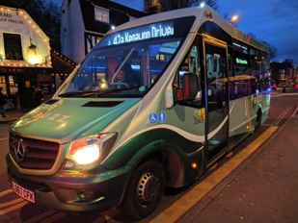
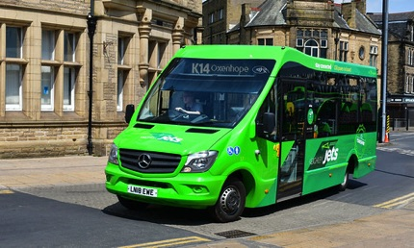
There are a significant number of public transport providers in Great Britain who use small buses to deliver services including the examples below from Reading Bus, Keighley Bus and Preston Bus. All the small buses used meet the DPTAC specification, mirroring Public Service Accessibility Regulations for larger buses.

(Image shows low-floor small bus operated by Reading Bus)
(Image shows a low-floor small bus operated Keighley Bus)
(Image shows a low-floor small bus operated by Preston Bus)
Specialised services
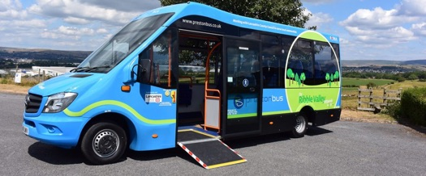
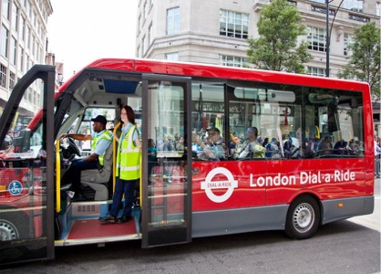
Many providers of services specifically designed for the use of disabled people and older people use small buses that meet the DPTAC Specification. These providers include Transport for London (London Dial-a-Ride), Strathclyde Passenger Transport (MyBus) and Bridge Accessible Transport (DATS) in Derry/Londonderry.

(Image shows a low-floor small bus operated by London Dial-a-Ride)

(Image shows a low-floor small bus operated by MyBus)

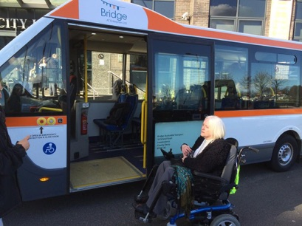
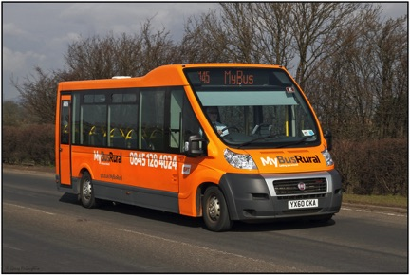
(Image shows a low-floor small bus operated by Bridge Accessible Transport)

Statutory providers
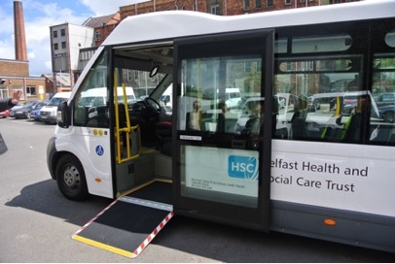
Both Belfast Trust and the Education Authority in Northern Ireland have purchased small buses that meet the DPTAC Specification.

(Image shows a low-floor small bus operated by Belfast Trust)
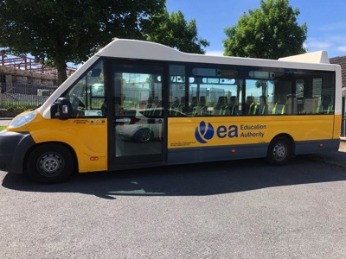

(Image shows a low-floor small bus operated by the Education Authority)
Appendix B - Revised Accessibility Specification for Small Buses designed to carry 9 to 22 passengers (inclusive)

Disabled Persons
Transport Advisory Committee
Revised Accessibility Specification for
Small Buses
designed to carry 9 to 22 passengers (inclusive)

The Disabled Persons Transport Advisory Committee (DPTAC) is a statutory body established under the Transport Act 1985. It advises government and industry on the transport needs of disabled people.

The Committee works under the auspices of the Department for Transport, Local Government and the Regions.

Chairperson: Neil Betteridge
Secretariat: DPTAC
Department for Transport, Zone 4/24, Great Minster House, 76 Marsham Street, London SW1P 4DR

Telephone 020 7944 3632
Facsimile 020 7944 6998
Minicom 020 7944 3277

DPTAC website www.dptac@dft.gov.uk

Crown Copyright 2007
Copyright in the typographical arrangement and design vest in the Crown

Applications for reproduction should be made in writing to
The Copyright Unit, Her Majesty’s Stationery Office, St Clements House, 1-16 Colegate, Norwich NR3 1BQ

Further copies of this document are available from: Department for Transport, free literature, PO BOX 236, Wetherby, LS23 7NB Tel: 0870 1226 236 Fax: 0870 1226 237

Acknowledgement: we are grateful to the Community Transport Association and Optare for the photographs.

This document is printed in Helvetica 14pt. It is also available in alternative formats on request and is available on the DPTAC website

October 2007
Product code: DPTAC 14

Contents
Introduction 3
Legislation 4
Scope of the DPTAC Specifications 5
The specification 6

Accessibility Specification
Entrances and Exits 7
Floors and Gangways 9
Internal Steps 9
Handrails and Handholds 10
Seats 11
Wheelchair Spaces 12
Entrances for use by Wheelchair Users 14
Boarding Aids 14
Wheelchair and Passenger Restraints 16
Heating and Ventilation 18
Luggage Space 18
Reversing Alarms 19
Bus Exterior 19
Exterior Signing and Advertising 20
Bell Pushes 20
Signs and Communications 20

Accessibility Specifications for Small Buses

Introduction

1. For some time the Disabled Persons Transport Advisory Committee (DPTAC) has been concerned about the standard of accommodation provided for disabled people in many minibuses and other small buses. This is particularly apparent when wheelchairs are carried in minibuses; insufficient space is often provided for both the safety and the comfort of the wheelchair users. However, the features for ambulant disabled people also fall short of the ideal.

2. In the absence of regulatory guidance in this area for small buses DPTAC first issued guidance in 2001. As a result of subsequent developments in vehicles design DPTAC has produced the following revised specification through its Bus and Coach Working Group, to promote best practice and to encourage and sustain improvements in the design and development of suitable vehicles.

The vehicles

3. These comprise a very wide range, including van conversions, chassis-built minibuses, and factory-produced mini- and
midi-buses including low floor designs. As the term minibus appears to have different meanings to different people, the term Small Bus is used.

4. Small Buses are defined as buses designed to carry 9 to 22 passengers (inclusive).

Types of Use

5. There are nearly 100,000 Small Buses in the UK. A significant proportion is used to transport disabled people, including many vehicles adapted to carry wheelchair users.

6. Small Buses are operated in a number of ways. Some are operated as public transport providing Local Services, including services operated by the voluntary sector under Section 22 permits.

7. Local Authorities operate many, directly or indirectly, for purposes such as Social Services and Education transport.

8. A large number are used for other forms of community transport, and by the “voluntary sector.” Some of these operate under Section 19 or Section 22 permits. In addition, other clubs and associations run them for various purposes.

9. Due to this diversity, many do not fall within a singular regulatory framework.

10. Of course, the design and specification of a vehicle is not the only factor in determining how far a service can be deemed to be fully accessible. Other issues that can render a service more or less accessible include: the way that a service is delivered (for example, the length of the journey, the ease with which bookings can be made, and so on); the way in which the vehicle is driven; the help and care given by drivers and assistants to passengers (and the way people are treated in general); the extent of training provided to drivers and assistants. Whilst it is clearly not possible to operate an accessible service with a vehicle that is not physically accessible, it is certainly possible to have an accessible vehicle and use it to run a service that is not at all suitable for people with various forms of mobility impairment.

11. This specification, which deals with the accessibility of the vehicle itself, is therefore part of a larger picture. Other factors influencing accessibility include operating procedures, training, driving skills and passenger assistance.

Legislation

12. At present there is no all-embracing UK legislation which covers the entire Small Bus sector. There is also currently no regulation covering the carriage of wheelchairs in these vehicles: the Department for Transport (DfT) document VSE 87/1 Code of Practice: “The Safety of Passengers in Wheelchairs on Buses” remains the main guidance available.

13. Proposals for regulations for Small Buses under the Disability Discrimination Act 1995 (DDA) will be considered. However, the scope of this provision is likely to exclude a significant number of Small Buses that may be intended to transport disabled people.
In 2001 the European Commission introduced Directive 2001/85/EC for the construction of all buses and coaches, including Small Buses. The directive includes provisions for passengers with disabilities but for small buses they are optional. However, provision is made for a Member State to mandate the directive and the accessibility provisions within its territory if it so wishes. Currently, for vehicles registered in the UK, manufacturers have the option of complying with the directive as an alternative to UK regulations.

The European Commission has put forward proposals to mandate the bus and coach directive for all buses and coaches including small buses. However, UK regulations may continue to apply to many small buses approved and registered in small numbers or as individual vehicles. The DfT is therefore developing proposals that are likely to replace existing rules and require all small buses to comply with the directive although not necessarily the accessibility provisions beyond those currently required.

Scope of the DPTAC Specification

14. The DPTAC specification for Small Buses is intended to address all the vehicles that are intended to be used to transport disabled people, irrespective of the vehicle construction.

15. This will include not only those small buses that have been specifically designed to carry people with disabilities, such as Dial-a-Ride, or Special Needs School transport, but also any small bus which provides a service which is open to the general public. This would include all Small Buses operated as public transport, (i.e. those used on Local Services), or non-emergency ambulances and transport for health appointments, for example.

16. The DPTAC specification Is not a statutory requirement. It is intended to promote best practice in meeting the needs of disabled people. It will be a matter for specifiers and operators, such as Local Authorities, to decide whether to adopt the DPTAC specification on a voluntary basis. Experience with DPTAC specifications for larger buses demonstrates that there will be progressive introduction of DPTAC specifications as a basis for tendering, resulting in vehicles offering both improved access and better travelling conditions. DPTAC will co-operate with others in the production of operating guidance in the use of small buses.

17. DPTAC welcomes the Government commitment in paragraph 6.5 of “Transport 2010 - the 10 Year Plan for Transport” that public investment in transport will be conditional on accessibility for disabled people being included. DPTAC’s strong advice is that local authorities and the devolved administrations should match this commitment, particularly - in the context of this document - when making vehicle procurement decisions.

The Specification

18. The specification was revised in 2007 to reflect developments in the design of low floor Small Buses but draws much of its technical content from the previous specifications which in turn were drawn up on the basis of existing guidance, and experience of the DPTAC specifications for larger buses. Important references included Vehicle Standards Engineering (VSE) 87/1, and local guidance documents from West Sussex County Council and the London Accessible Transport Unit, as well as other DPTAC specifications and the Disability Discrimination Act 1995 Public Service Vehicle (PSV) Accessibility Regulations 2000. Such documents have been founded on a wide basis of research, particularly by the DfT over many years into the needs of people with disabilities. Additional research was also conducted into such areas as wheelchair sizes, and passengers’ views of existing vehicles. There has also been extensive preliminary consultation with a number of bodies and individuals, including users, specifiers, operators and vehicle manufacturers.

19. Due to the development of low floor Small Buses a single specification replaces the previous two but continues to make provision for the different operating conditions of local service and non local service use.

20. This specification provides a minimum standard of accessibility for disabled people.

21. The specification covers features required by all disabled passengers and additional features required for wheelchair users. Wheelchair access is required for vehicles used on local services but is not be required for all vehicles, only those which are intended and designed to carry wheelchair users. Wheelchair access should ideally be incorporated in all vehicles providing services to the general public, or in any vehicles intended for use by disabled people. Features which assist wheelchair users may also be used by ambulant disabled people.

Accessibility specification (Revised 2006)

1. Entrances and Exits

1.1 Passenger entrances/exits (excluding any emergency exits), and the area(s) immediately outside these, must be well lit, including illumination at foot level, when passengers are boarding and alighting.

1.2 Primary Entrance

At least one nearside passenger entrance is to be designated as the primary entrance and is to have:

1.2.1 A single step with a maximum height above ground level of 250mm when the vehicle is in the loading position, which may be achieved by means of a kneeling mechanism. There are to be no subsequent steps in this entrance.

1.2.2 The step nosing and entrance flooring of slip-resistant material, with the nosing finished in a bright colour contrasting with the colour of the floor/step surface.

1.2.3 A transverse slope in the floor of not more than 5˚ (approximately 1 in 12 or 8%) measured with the vehicle unladen in its normal ride position may be permitted within 1000mm of the entry step.

1.2.4 A minimum unobstructed space through this entrance of 800mm wide, and 1800mm high from the floor measured in the vertical plane.

1.3 Primary Exit

1.3.1 At least one nearside passenger exit is to be designated as the primary exit.

1.3.2 This may either be combined with the primary entrance or be separate.

1.3.3 If it is separate, it must meet the same conditions as the primary entrance in Section 1.2

1.4 Secondary Entrances

1.4.1 Any secondary passenger entrances are to be compliant with paragraph 1.2.2.

1.4.2 Any secondary entrance with a single step is also to be compliant with paragraphs 1.2.3.

1.4.3 Any secondary entrance with more than one step is also to have:

1.4.3.1 A maximum first step height of 250mm above ground level, which may be achieved with a folding or slide out step or kneeling mechanism.

1.4.3.2 Each subsequent entrance/exit step (maximum two) which is to be between 120mm and 250mm high with the risers consistent in height to within 10mm. The required number of steps are to be grouped together. Risers are to be vertical and closed, and have a smooth flat surface with no protrusions. Any lights incorporated into risers should be flush-mounted.

1.4.3.3 Step treads with a minimum depth of 280mm (300mm preferred).

1.4.3.4 A minimum unobstructed space through this entrance of 650mm wide.

2 Floors and Gangways

2.1 At least 50% of the passenger accommodation is to form a single low floor area free of any steps. Step free access is also required between the low floor area and the primary entrance and primary exit.

2.2 All floors and gangways should be level when the vehicle is in the normal ride position and covered with a slip-resistant material. A slope of not more than 3º degrees (approximately 1 in 20 or 5%) with the vehicle unladen and in its normal ride position, is permitted.

2.3 Other than gangways for wheelchair access, gangways are to be at least 450mm wide, from floor level up to 1400mm above the floor, increasing to a minimum of 550mm wide at or above 1400mm.

2.4 Minimum clear headroom must be 1800mm throughout the saloon area except in the areas within 150mm of the side walls, and above fixed seats and wheel arches..

3 Internal Steps

3.1 Any steps in a gangway beyond the low floor area must be grouped together, and be between 120mm and 200mm in height with the risers consistent in height to within 10mm. Step treads must be at least 300mm deep. Risers must be vertical and closed, and have a smooth flat surface with no protrusions. Any lights incorporated into risers are to be flush mounted. All step nosings and treads are to be finished in a slip-resistant material, with nosings finished in a bright colour contrasting with the colour of the floor/step surface.
4 Handrails and Handholds

4.1 All handrails and handholds must have a circular cross-section, with a diameter of between 30mm and 35mm. There should be no sharp bends (e.g. mitred corners of 90˚ or less) in handrails. There must be a minimum clearance of 45mm (preferably 50mm) between handrails or handholds and any adjacent surface.

4.2 Handrails must have an easily gripped slip-resistant surface, preferably with a “rigidised” or similar raised texture, and in a bright colour which provides a clearly visible contrast (both in colour and tone) with the interior colour scheme and seat covering.

4.3 At primary entrances and exits and secondary entrances with a single step, handrails must be provided giving a rigid handhold (which may be fixed to the inside of the door leaf provided the leaf does not significantly move when the handrail is in use), and which incorporate:

(i) a vertical section on each side of the entrance from a point not more than 550mm above the step to a point not less than 850mm above the step, which is to be mounted no more than 100mm inboard of the step nosing measured in the horizontal plane when the door(s) is (are) open, and

(ii) a horizontal handrail on one side of the entrance (preferably both), mounted at a height of 800mm to 900mm above the floor which extends from a point not more than 150mm inboard of the step nosing measured in a vertical plane for at least 350mm into the entrance.

4.4 One handrail complying with 4.3(ii) is to be extended beyond the entrance to at least the first forward facing priority seat. Where this cannot be achieved due to any necessary breaks in this handrail, this is to be compensated for by suitably placed additional vertical handrails within the height range of 1200mm to 1500mm which provide a maximum reach of not more than 1050mm.

4.5 At secondary entrances with more than one step, handrails must be provided on both sides of each entrance to give a rigid handhold parallel with the slope of the steps from a point not more than 100mm inboard of the outer edge of the first fixed step to a point not less than 100mm beyond the nosing of the top step, at a height of 800-900mm above the step nosings. Handrails may be fixed to the inside of the door leaves provided they do not significantly move when the handrail is in use.
At doorways wider than 850mm an intermediate handrail must be provided to give a minimum width between handrails of 650mm, and a maximum of 850mm, on at least one side.

4.5 The tops of all fixed gangway seat backs must be fitted with a rigid vertical handrail. For removable or folding seats, the tops of seats adjacent to the gangway must have a rigid handhold, which may be a corner mounted grab handle on the gangway side or a top mounted grab handle. Such grab handles must be padded or similarly protected to minimise risk of head injury. On any seat location where no such handhold or vertical rail is available in front of the seating position (e.g. a front row seat facing a bulkhead or in seats facing a wheelchair position) a horizontal handrail or vertical stanchion must be provided for this purpose.

4.6 Adequate handrails must be placed adjacent to any internal steps.

5. Seats

5.1 Other than for priority seats specified in paragraph 5.6, the minimum size of seat cushion for each passenger is 425mm wide (measured at the leading edge) and 400mm deep (measured through the centre line of the cushion top).

5.2 The top of each seat cushion (measured at the leading edge) must be between 430mm and 490mm above the floor immediately in front of the seat. The clear headroom above each seat must be at least 1250mm from the top of the seat cushion (measured in the vertical plane from the centre of the leading edge).

5.3 The distance between the front surface of the seat back and the back of the seat(s) in front is to be at least 650mm (measured at the centreline), and the minimum space between the leading edge of the seat cushion and the seat or fixture in front must be at least 250mm (measured in the horizontal plane). If facing pairs of seats are provided, the minimum distance between the leading edges of the facing seat cushions is to be not less than 500mm.

5.4 All seats are to be either forward or rearward facing.

5.5 The requirements in paragraphs 5.1, 5.2 and 5.3 apply to folding seats when these are in the deployed position.

5.6 Two forward-facing seats in the low floor area, preferably those nearest to the primary entrance, which are not folding seats, are to be provided as priority seats for elderly and disabled passengers. These are to be clearly marked with an appropriate notice, incorporating a pictogram, to indicate their purpose. There is to be an extended space (i.e. knee-room) of at least 300mm in front of the leading edge of the priority seat cushion (measured in the horizontal plane), and adequate space under or adjacent to them for an assistance dog to lie down. Priority seats are to be at least 450mm wide (measured at the leading edge of the cushion).

6 Wheelchair Spaces

6.1 There must be at least one designated wheelchair space provided within the low floor area with wheelchair access from the primary entrance or primary exit. Except as provided for in paragraph 6.6, a wheelchair space is to be not less than 750mm wide and 1300mm long.

6.2 It must be possible for a reference wheelchair - (see Annex A) - to be moved from the wheelchair entrance to the designated wheelchair space and from the wheelchair space to the wheelchair exit. This must be done with the wheelchair user moving in a forward direction and requires sufficient space to be provided for the wheelchair to be manoeuvred into and out of the designated space and for the wheelchair to be turned around within the combined area of the designated space and the adjacent gangway.

6.3 A minimum gangway width of 750mm at any point, from floor level to a height not less than 1400mm above the floor, from the wheelchair entrance and exit to the designated wheelchair space.

6.4 Where the wheelchair space or the access to it may overlap with the foot space in front of a seat or a folding seat when in use, a notice is to be displayed requiring the seat to be given up when the space is required by a wheelchair user. Any such seat is not to be designated as a priority seat referred to in paragraph 5.6.

6.5 Except as provided for in paragraph 6.6, all wheelchair spaces must be within the low floor area and a minimum gangway width of 750mm is required at all times between each additional wheelchair space and either the primary entrance or exit or an alternative entrance which is wheelchair accessible (i.e. provides a minimum width of 750mm).

6.6 Where space for more than one wheelchair is provided on a bus which operates to and from a single destination such as a Park & Ride service, where it is possible for the last wheelchair passenger to board to alight first:-

(i) the minimum gangway width of 750mm does not need to be adhered to other than between the first wheelchair position and the wheelchair entrance and exit,

(ii) beyond this the gangway requirements in paragraph 2.3 are to be met for access to all seats which are available for passenger use (i.e. excluding any seats folded out of use to provide space for wheelchairs), and

(iii) the amount of space set aside for each additional wheelchair may be varied to accommodate particular wheelchairs and the restraint systems referred to in paragraph 9..

6.7 Personal access to emergency exits must be maintained; an unobstructed width of less than 350mm is unlikely to permit emergency egress of people.

7 Entrances an exits for use by Wheelchair Users

7.1 All doorways intended for use by passengers in wheelchairs are to have a clear unobstructed width of at least 800mm from floor level up to a height of at least 1800mm at the point of entry.

7.2 Where such a doorway is not within the driver’s direct field of view, it is to be provided with a push button on the outside of the vehicle near to the relevant door to request operation of a boarding aid. This button is to be mounted on the near side of the vehicle as close as possible to the doorway between 850mm and 1100mm above road level, be capable of operation with the palm of the hand, colour-contrasted with its surroundings and illuminated when ready for use.

8 Boarding Aids

8.1 All entrances and exits for wheelchair users must have a boarding aid i.e. a ramp or a passenger lift. Ramps and lifts are also for the use of ambulant disabled people, and facilitate access for many other people, including those with pushchairs, luggage or shopping trolleys.

8.2 Ramps

8.2.1 Access ramps must be capable of taking a minimum weight of 300kg and must have a slip resistant surface not less than 800mm wide. Due to the fact that some mobility aids are three-wheeled, and also that it is unsafe for an attendant to reverse a wheelchair down them, channel ramps must not be used. The transition from the ramp into the vehicle must avoid severe changes of gradient, and every effort must be made to eliminate any vertical projections at the point where the ramp links to the floor in the doorway. Access ramps must also be capable of extending to ground level.

8.2.2 Deployment of a powered ramp must be indicated by an audible signal. Clear warning notices should be displayed to advise passengers not to board a moving ramp.

8.2.3 Ramps should be of such a length as to provide a maximum slope of 7˚ (approximately 1 in 8 or 12%), measured with the vehicle suspension lowered if appropriate. This is the maximum slope which many wheelchair users can manage independently, and which also reduces the hazard of an attendant having an unacceptable load when boarding or alighting a wheelchair user.

8.2.4 For buses fitted with a ramp at a side entrance the maximum ramp slope is measured with the ramp fully extended to a reference kerb height of 125mm. It is also important to ensure that the ramp length does not cause excessive intrusion onto the pavement.

    - For rear entrances, the maximum ramp slope is measured to ground level. The ramp length must not exceed 2.7 metres. As a consequence, and of paragraph 8.2.3, vehicles with a wheelchair entrance height in excess of 330mm when in the boarding condition should not be fitted with a ramp. For vehicles where the boarding position is above this height, a lift is required.

8.2.6 If a portable ramp is used it must be carried on the vehicle at all times and must always be available for intending users. It must be securely located when deployed, and be securely stowed when not in use.

8.3 Passenger Lifts

8.3.1 A power-operated passenger lift must have a load-bearing capacity of at least 300kg, and have a platform size of at least 750mm wide and 1200mm long when deployed.

8.3.2 Passenger lifts should have colour contrasted handrails on both sides.

8.3.3 Deployment of a passenger lift must be indicated by an audible signal. Clear warning notices should be displayed to advise passengers not to board a moving lift.

- Wheelchair and Passenger Restraints

  - In vehicles which may carry standing passengers and are not equipped with seat belts, wheelchair users may travel unsecured, provided that they are positioned in a designated rearward facing wheelchair space which accords with all of the following:

(i) The wheelchair space must be fitted with a backrest at the forward end of the space, positioned centrally within the wheelchair space, and incorporating a padded surface facing the rear of the vehicle;

(ii) The backrest meets the following dimensions:

1. Bottom edge not less than 350mm and not more than 480mm above the floor

2. Top edge not less than 1300mm above the floor, measured vertically from the floor

3. Width to be not less than 270mm and not more than 420mm up to a vertical height of 830mm from the floor, and between 270mm and 300mm above this height

4. Fitted at an angle of not less than 4˚ and not more than 8˚ such that the base is further rearward than the top

5. The padded surface is a single and continuous plane which passes through a transverse line 100mm to 120mm (measured horizontally) from the front end of the wheelchair space at a point between 830mm and 870mm vertically above the floor.

(iii) The backrest is designed to bear a load of 2000N for a minimum of 2 seconds towards the front of the vehicle such that the backrest does not deflect more than 100mm or suffer permanent deformation or damage.

(iv) Within the wheelchair space, a clear space of not less than 750mm wide must be maintained and, in order to restrict the lateral movement of a reference wheelchair, there shall be a distance not greater than 900mm (measured in the lateral plane of the wheelchair space) between any two of the following adjacent means of support fitted on each side of the wheelchair space -

1. a vertical stanchion situated to the rear of the front end of the wheelchair space and running continuously from the floor of the wheelchair space to a height of not less than 1500mm, which shall comply with the following requirements -

(a) the base of the stanchion shall be not less than 400mm and not more than 560mm from the front end of the wheelchair space measured horizontally,

and

(b) at heights exceeding 775mm measured vertically from the floor of the wheelchair space, the stanchion shall be not less than 540mm and not more than 560mm from the front end of the wheelchair space measured horizontally;

or

2. a retractable rail extending continuously from a point not more than 200mm from the front end of the wheelchair space to a point not less than 540mm from the front end of the wheelchair space measured horizontally and at a height of not less than 600mm and not more than 800mm measured vertically from the floor of the wheelchair space;

or

3. a partition extending continuously from a point not more than 200mm from the front end of the wheelchair space to a point not less than 540mm from the front end of the wheelchair space measured horizontally and at a height of not less than 600mm and not more than 800mm measured vertically from the floor of the wheelchair space;

or

4. the side wall, or equipment fitted to the side wall, of the vehicle extending continuously from a point not more than 200mm from the front end of the wheelchair space to a point not less than 540mm from the front end of the wheelchair space measured horizontally and at a height of not less than 600mm and not more than 800mm measured vertically from the floor of the wheelchair space.

(v) A horizontal handrail is to be fitted along one side of the space at a height of 850mm to 1000mm measured vertically from the floor, to run continuously from a point not more than 300mm to the rear of the front end of the wheelchair space measured horizontally to a point not less than 1000mm to the rear of the front end of the wheelchair space measured horizontally, which does not intrude more than 90mm (measured horizontally) into the space.

(vi) an additional passenger restraint may be fitted to provide additional passenger security.

9.2 (i) Other than as provided for in paragraph 9.1 wheelchairs must be carried forward facing, and are to be secured (restrained) before travel by a wheelchair restraint system.

(ii) Wheelchair restraints must, as a minimum, conform to the requirements of VSE 87/1 Code of Practice “The Safety of Passengers in Wheelchairs on Buses”, or to a recognised equivalent standard such as the requirements of bus and coach Directive 2001/85/EC, Annex VII.

(iii) Any passenger travelling in a forward facing wheelchair is to be secured before travel with either a 3-point passenger restraint (lap and diagonal belts) or a full harness passenger restraint anchored to the vehicle.

9.3 Instructions for the correct use of wheelchair restraints must be provided adjacent to the wheelchair space(s). the use of pictograms is recommended.

10 Heating and Ventilation

10.1 An adequate system of heating and ventilation should be installed to ensure that a reasonable temperature and air quality is maintained in the passenger area.

11 Luggage Space

  - All buses must have luggage space for the safe storage of shopping bags, trolleys or folded pushchairs, etc.

  - The minimum recommended volume is 0.21 cubic metres which may be achieved by a pen of 500mm wide by 600mm long by 700mm deep.

Unoccupied wheelchairs carried in the passenger compartment of the vehicle are to be firmly secured before the vehicle is in motion, and positioned so that they do not create an impediment or hazard to passengers.

A suitably labelled storage receptacle or space should be provided for loose safety straps and wheelchair restraints.

12. Reversing Alarms

12.1 An audible external reversing alarm should be fitted for automatic use in conjunction with reverse gear, but with provision for the driver to override during prohibited hours.

13. Bus Exterior

13.1 Buses used on local services must comply with the following:

- All route number and destination displays are to be clearly visible by day and by night under all lighting conditions (including bright sunshine) and are to use white or bright yellow numerals and letters on a black background.

(ii) On the front of the bus above the windscreen there is to be a route number display at least 200mm high, preferably to the right (nearside) of an ultimate destination name in letters at least 125mm high. A route number at least 70mm high (together with the destination wherever possible) is to also be clearly displayed at or a little above eye level on the nearside, adjacent to the primary entrance door. Ideally, the route number (200mm high) should be displayed on the rear of the bus.

14 Exterior Signing and Advertising

14.1 Buses used on local services must comply with the following:

- The standard international wheelchair symbol (white on blue) should be displayed on the front of the bus so that wheelchair users are able to recognise accessible vehicles.

(ii) No advertising material other than passenger information relevant to the services will be fixed to the door(s) or windows.

15 Bell Pushes

15.1 Bell pushes should be provided on vehicles which are used on any service operating on a request stop basis (i.e. except where the driver has a prepared schedule of where passengers require to be set down or there is a single set down point). Plastic bell strips and ceiling-mounted bell pushes are not to be fitted. Bell pushes should operate the signs mentioned in 16.1.

15.2 Bell pushes must be mounted on fixed vertical handrails, sidewalls or bulkheads so as to be within reach of any passengers in wheelchairs, passengers seated on the priority seats and at every third row of seats (ideally at every row). Bell pushes adjacent to seats and wheelchair spaces are to be positioned between 700mm and 1200mm above the floor and between 1100mm and 1500mm above the floor for all other locations.

15.3 The bell push surround and the bell push are to be in bright colours (e.g. yellow and red) which contrast with the surface on which they are mounted and with each other. The bell push is to project sufficiently from the surround so that it can be operated by the palm of the hand.

16 Signs and Communications

16.1 Buses used on services operating on a request stop basis must have clearly-visible illuminated signs reading “Stopping” or “Bus Stopping” capable of being seen by all passengers in the bus, and are to remain illuminated until the doors are opened.

16.2 Other signs in the bus are to be clear and in as large a print as practicable, drawing attention, for example, to the availability of concessionary fare schemes for elderly or disabled passengers. In particular, notices indicating emergency exits or the location of fire extinguishers and first aid boxes (if fitted) are to be clearly visible to the maximum number of passengers.

16.3 A public address system is a useful option, to enable announcement of stop names and destinations, and to give other information to passengers, especially those who are blind or partially sighted or in need of special help.

16.4 Tactile plates with raised symbols mounted on entrance and exit handrails can help blind or partially sighted passengers to distinguish features such as the number of steps. These may be fitted where agreement has been reached with local organisations representing blind or partially sighted people, thus ensuring that the message the plates convey will be understood.

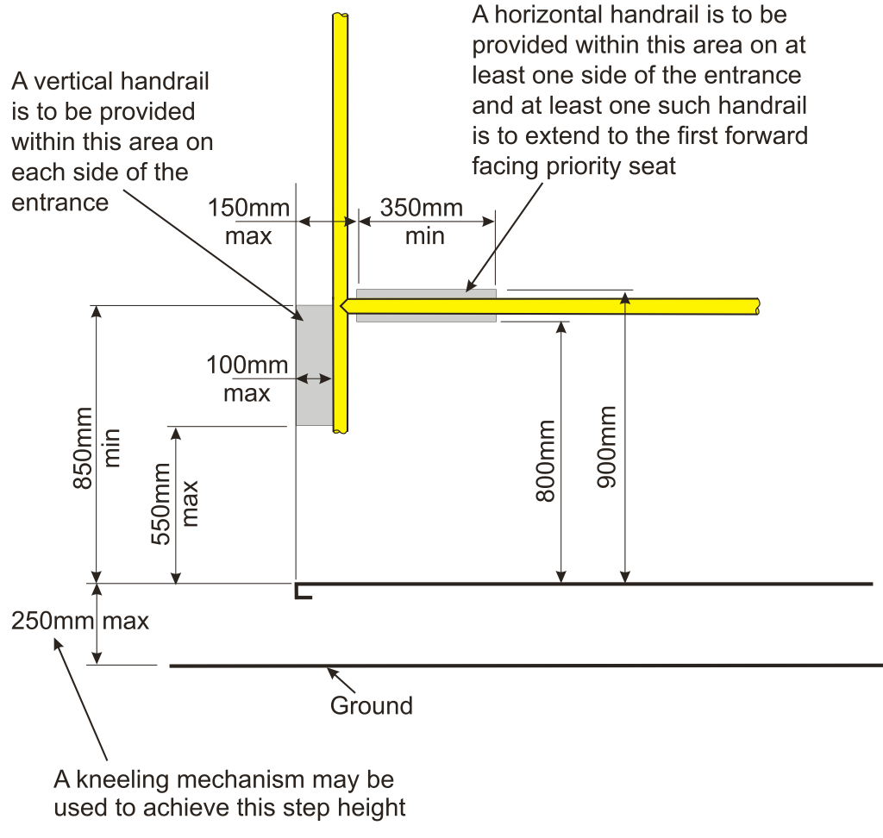

Diagram 1 Steps and handrails – primary entrance

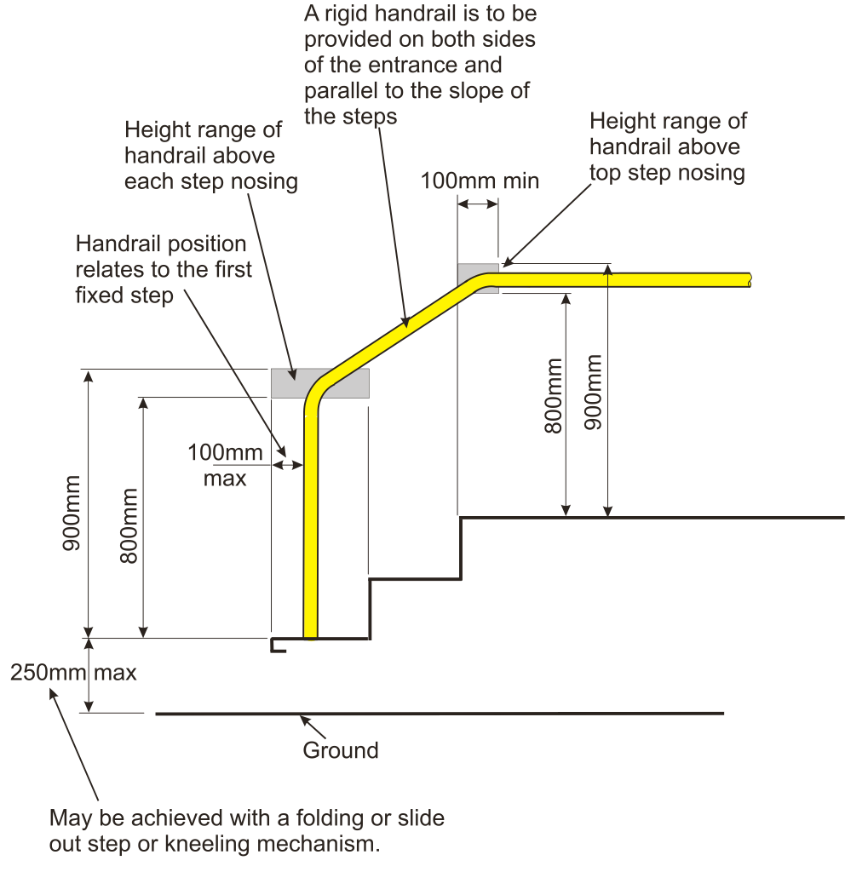

Diagram 2 Steps and handrails – secondary entrance

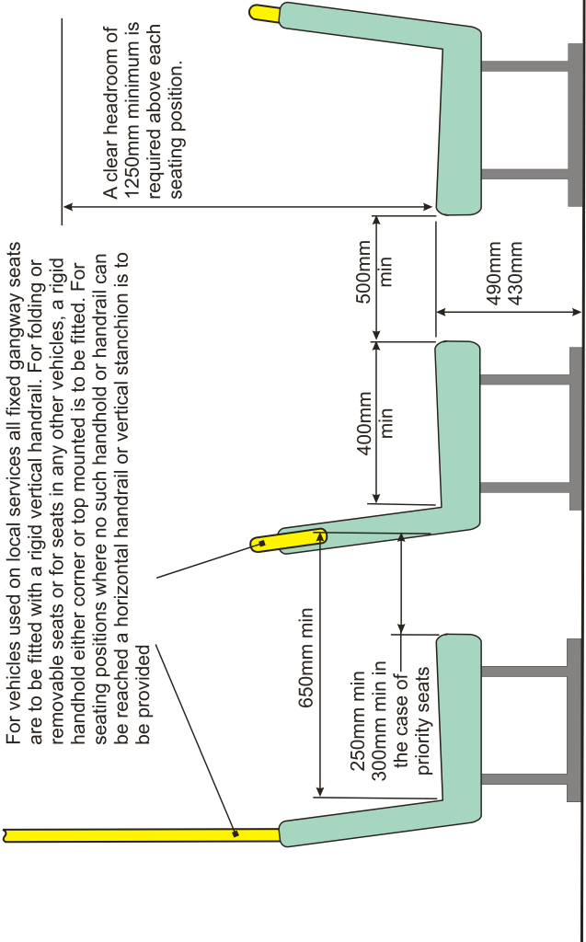

Diagram 3 Seat spacing and handrails

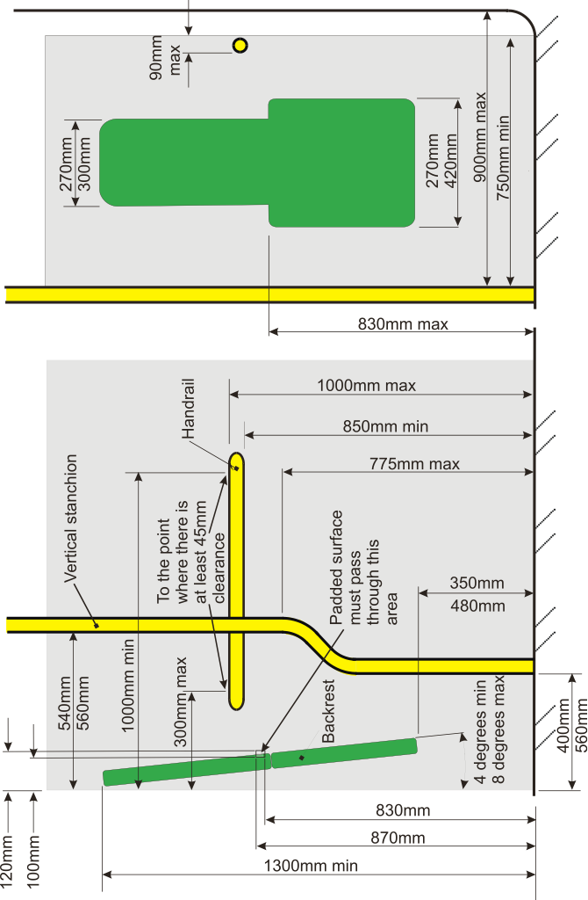
Diagram 4 Wheelchair space – rear facing

Annex A Diagram wheelchair dimensions – reference wheelchair

https://webarchive.nationalarchives.gov.uk/20080731162434/http://www.dptac.gov.uk/pubs/smallbus2007/index.htm
For more information about 10B permits visit https://ctauk.org/cta-advice-service/faq/what-is-a-section-10b-permit-and-do-we-need-one/
See https://www.nidirect.gov.uk/articles/bus-operator-licensing
See http://www.legislation.gov.uk/ukpga/1995/50/contents
See https://www.imtac.org.uk/publications/belfast-trust-minibuses-benefits-low-floor-design
https://www.northernireland.gov.uk/sites/default/files/publications/newnigov/dp-average-journey-time-on.PDF
“To enable persons with disabilities to live independently and participate fully in all aspects of life, States Parties shall take appropriate measures to ensure to persons with disabilities access, on an equal basis with others, to the physical environment, to transportation, to information and communications, including information and communications technologies and systems, and to other facilities and services open or provided to the public, both in urban and in rural areas.”
The Accessible Transport Strategy (ATS) 2025: Our views on the vision, strategic priorities and how to measure success for a new ATS

