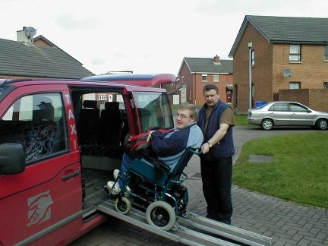

Imtac Factsheet 12
Using Taxis

What you need to know

- Most taxis are ordinary cars
- There are some taxis accessible to wheelchair users
- Drivers should not charge extra to carry a wheelchair and other aids in the boot
- All taxi fares in Northern Ireland are regulated – you should not be charged more than the Maximum Fare
- Taxi drivers should not refuse to carry your guide or assistance dog
- Taxi drivers usually will help you to and from the taxi

Things to think about

- Ask other people which companies provide a good service
- Be sure the company has a taxi that suits your needs
- If you are a wheelchair user and can transfer by yourself ask for an ordinary taxi
- When booking a taxi by phone agree a price in advance and tell them about your access requirements
- Is there other transport available that you could use for your journey eg DATS

Useful Information

Information about taxis is generally not good. You can get more information by:

- Talking to other people about who are the best in your area

- Searching online

- You may also want to visit the NI Direct website at https://www.nidirect.gov.uk/information-and-services/public-transport/taxis

You might want to look at these other factsheets :-

Transport and Your Rights
Planning Your Journey
If Things Go Wrong
Rural Transport and Dial-a-Lift
DATS

