Imtac Annual Report 2010

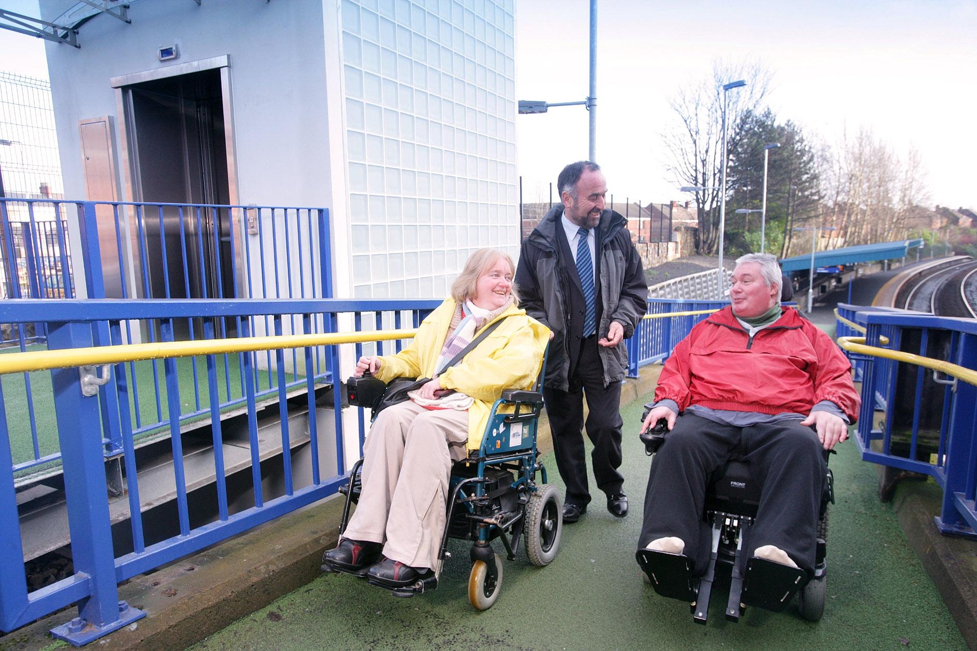

This report is available in alternative formats including an easy read version. Please contact us to discuss your requirements.

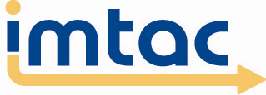
September 2010

1 About Imtac

Imtac is a committee of disabled people and older people as well as others including key transport professionals. Our role is to advise Government and others in Northern Ireland on issues that affect the mobility of older people and disabled people.

Our aim is to ensure that older people and disabled people have the same opportunities as everyone else to travel when and where they want.

Imtac receives support from the Department for Regional Development.
2 About this report

The Accessible Transport Strategy (ATS) requires Imtac to produce an annual report with details of our achievements over the previous year. We are also required to identify key issues that we would advise the Department for Regional Development (DRD) to address in the coming year and submit these to the Minister.

3 Chairs Message

This year has been another busy year for Imtac. Our members continue to attend numerous meetings, contribute to papers and consultations. I would like to pay tribute to commitment shown by all our members over the past year.

Our work this year has been diverse as ever covering issues such as rights for disabled people and older people using transport, audio and visual information on buses, driver licensing, access to air travel, access to our town and city centres, parking and door2door. We continue to work with a range of stakeholders to ensure disabled people and older people are involved in the development of policy and services.

Our work over the past 5 years has illustrated how important it is for policy makers and service providers to engage with older people and disabled people. I believe that our work during this time shows that engagement results in better policy and services and ensures that the benefits of investment are maximised. Given the current difficult financial situation engagement with disabled people and older people is more important than ever. Over the next year Imtac will work with all our partners to ensure this happens.

Frank Caddy
Chair

4 Our achievements in 2009/2010

Working to promote rights

This year saw the introduction of new rights for disabled people when using transport services in Northern Ireland. Imtac worked with the Equality Commission around the development of the campaign to promote the rights and guides to the new rights for both disabled people and transport providers.

During the year we continued to work with the Consumer Council to promote the rights of older people, disabled people and others with reduced mobility when travelling by air. Imtac assisted the Consumer Council in developing a Guide for people around rights when travelling by air.

In the coming year we plan to work with both the Equality Commission and Consumer Council to look at ways to make more disabled people and older people aware of their rights when using transport.

Working to improve access to transport

Imtac continues to work hard to ensure that disabled people and older people have the opportunity to use the range of public transport services that operate in Northern Ireland.

We continue to work in partnership with Translink. During the year we helped Translink to get feedback from disabled people and older people on the design of new trains. We worked with Translink and others on disability training for staff and finalized a new Access Guide to services.

We also looked at other forms of transport. Imtac responded in detail to a consultation from the Department for Transport aimed at improving access to taxis. Locally we worked with Roads Service to look at the accessibility of taxi ranks here. We developed a paper advising on possible changes to the door2door scheme here including best practice around the design of vehicles used. We also highlighted the potential benefits of introducing audio and visual information on buses here and the need to make information about services more accessible. Alongside the Consumer Council we have also continued to work with local airports to improve access to services. This year we assisted in organizing site visits for older people and disabled people to Belfast City and International Airports

We also sought to advise around future policy developments around access to transport. We contributed to the consultations on Public Transport Reform and a future Regional Transportation Strategy. We also made a submission to the Regional Development Committee inquiry on Sustainable Transport.

In the coming year Imtac will be looking to work with all our partners to improve access to services here.

Working for people who rely on the car for mobility

Many disabled people still rely on the car or private transport to get around and much of our work reflects this.

This year we looked at issues around driver licensing and assessment. We worked with Disability Action to revise correspondence sent to people required to attend driving assessments at the Northern Ireland Mobility Centre.

We continued to work with Roads Service to look at ways misuse of the Blue Badge Scheme can be better enforced. We also organized the 3rd Baywatch Survey in Northern Ireland. The results of the survey highlighted that over 1 in 5 accessible parking bays are abused here at any time.

During the year we also advised Roads Service on traffic management issues in towns and cities in Northern Ireland seeking to ensure that access for Blue Badge holders is a key consideration in any proposals. We worked with Roads Service to organize a workshop with disabled people to discuss parking opportunities in Belfast City Centre and responded to the consultation on access to pedestrian areas.

In the coming year we will continue to focus on access for people who rely on access to a car for mobility.

Working for safer streets and roads

Safe and accessible streets are an essential part of an accessible transport system.

Over the past year Imtac has again focused on major public realm improvements to our towns and cities and Belfast in particular. We responded in detail to the consultation on the Access and Mobility Study for Belfast City Centre and agreed a number of actions with the Department for Social Development in follow up meetings including looking at accessible walking routes between the city centre and key public transport stations.

We developed and published a policy paper highlighting our concerns around the growing use of shared space concepts. We advised Government not to use such schemes until research is carried out into their safety.

We continued our work for safer pavements focusing in particular on the shared use of pedestrian and cycling facilities. We advised Roads Service on a number of specific shared use schemes. We also held meetings with cycling officers within Roads Service as well as organisations representing cyclists to discuss concerns around schemes.

In the coming year safer streets and roads will remain a priority for Imtac.

Working with older people and disabled people

Most aspects of our work reflect issues that affect disabled people and older people. To do this effectively Imtac needs to ensure we engage with older people and disabled people and their organisations.

We continue to work hard to do this. Over the past year Imtac has sent out information about a range of mobility and transport related issues. In addition we publish all information about our work on our website as well as details about service and policy developments. We have also promoted our annual recruitment and received over 4 times the number of applicants than we had places. The vast majority of applicants are older people and disabled people.

We continue to meet with older people and disabled people from across Northern Ireland. This year we meet with people from Belfast, Craigavon, Ballymoney, Newtownards and Toome. We also assisted the Research & Library services at the Assembly to organize an event around accessible transport which was attended by over 50 disabled people and older people from across Northern Ireland.

We continue to encourage disabled people and older people to get involved in our work and wider developments in transport. This year we worked with people with a learning disability and their organisations to develop a report assessing how investment has improved access to transport. We encouraged people to get involved in key consultations and our work with Translink. Finally we encouraged people to become involved in our work with the Consumer Council and local airports.

During the last year our members have also represented Imtac on groups and committees with an interest in older peoples and disabled peoples issues. These Groups include the Older Persons Advocate Transport Forum, the transport group of the Age Sector Platform, the Rural Community Network Skills For Solutions Group and the All Assembly Group on Disability.

Over the next year we will look at others ways disabled people and older people can get involved in the work of Imtac.

5 Building on progress – Issues for
Government

Imtac will continue to work hard over the next year with all our partners to ensure that travel choice for disabled people and older people improves. We have agreed a Work Programme with the DRD for the coming year which is available on our website via the following link – www.imtac.org.uk/publications.php?pid=168.
Alternatively hard copies and copies in other formats are available by contacting us at our office (see Section 8).

Clearly the coming years will be difficult for everyone in Northern Ireland. For Government the opportunities for investment will be limited and difficult choices will have to be made about prioritizing resources. In this environment it is inappropriate for Imtac to identify unrealistic initiatives. We do however welcome the proposal from DRD to pilot of audio-visual information on buses here and hope this can be achieved in the coming year.

Imtac believes that because of previous investment in transport services there are many more potential travel opportunities for disabled people and older people. Given that further resources are not available Imtac believes that it is essential that Government and services providers work to ensure the policies of the Accessible Transport Strategy are fully implemented. This will ensure that all investment in transport maximizes benefits for older people and disabled people.

Difficult decisions will have to be made about allocation of resources. Imtac would ask that the impact on disabled people and older people be a major consideration in making future spending decisions and that engagement with the Committee is part of this process.

6 Thanks

Imtac would like to thank all those who contributed to our work over the past year. Special thanks are reserved for Henry Mayne, Anita Gracey, Joe McCusker, Neil Gillan and Dessie Ferguson who all stood down from the Committee after a number of years as members. Thanks also to the following people who contribute to our work through our working groups: Stephen Hughes (Roads Service), Orla McCann (Disability Action), Andrew Adams (DRD), Adele Watters and Sharon Clements (DoE) Fiona Mark (Consumer Council), Naomi Roberts (Equality Commission) and Claire Costello and Valentina Wright (both Translink). Special thanks to the staff and volunteers at Shopmobility Belfast for their help with the Baywatch Survey. Thanks also to Janet Watson (DRD) for all her help with the organisation of meetings.
7 Imtac Members 2009/10

Frank Caddy Chair
William Stewart Vice-Chair
Kellie Armstrong
Elizabeth Black
Philip Blair
Terry Butler
Ann Collins Convenor Personal Mobility Group
Dessie Ferguson
Barbara Fleming Convenor Public Transport Group
Ann Gamble
Neil Gillan
Anita Gracey
Francis Hughes
Etta Mann
Henry Mayne
Norma Moore
Joe McCusker (Resigned September 2009)
David McDonald Convenor Information & Training Group
Andrew Murdock
Max O’Brien
Ronnie Patterson
Laura Slater (co-opted September 2009)

More information on our members is available on our website, visit www.imtac.org.uk.

Observers

Olaf Hvattum Age Sector Platform
Kevin Doherty Disability Action
Tony O’Reilly Equality Commission for Northern Ireland
Deborah Howe Equality Commission for Northern Ireland
Gavin Hamilton Mobility and Inclusion Unit (DRD)
Alan Preston Mobility and Inclusion Unit (DRD)
Janet Watson Mobility and Inclusion Unit (DRD)
Ryan Simpson General Consumer Council
8 Contacting us

You can contact us about any aspect of this report or request it in an alternative format at:

Imtac
Enterprise House
55-59 Adelaide Street
Belfast
BT2 8FE

Telephone: 028 9072 6020
Textphone: 028 9072 6016
Fax: 028 9024 5500
Email: info@imtac.org.uk
Website: www.imtac.org.uk

